**SRI SIVASUBRAMANIYA NADAR**

**COLLEGE OF ENGINEERING**

(AFFILIATED TO ANNA UNIVERSITY, CHENNAI)

RAJIV GANDHI SALAI (OMR), KALAVAKKAM – 603110

**LABORATORY RECORD**

**IT8711-FOSS and Cloud Computing Laboratory**

Name : ............Harshavarthini K...............................

Reg. No. : ............312217205035....................................

Dept. : ............IT............. Sem. : ......VII...... Sec. : ...A......



**ANNA UNIVERSITY**

**BONAFIDE CERTIFICATE**

Certified that this is the bonafide record of

the practical work done for the

........**IT8711-FOSS and Cloud Computing Laboratory**......... lab

by

Name ..................Harshavarthini K..............................

Register Number .................312217205035........................

of Department of .........INFORMATION TECHNOLOGY..............................

Sri Sivasubramaniya Nadar College of Engineering,

Kalavakkam, Chennai

during the academic year ....2020-2021..

Staff In-Charge Head

Department of ...........IT..............

*Submitted for the University Examination held at*

*Sri Sivasubramaniya Nadar College of Engineering on ....................................*

Internal Examiner External Examiner

|  |  |  |  |  |  |
| --- | --- | --- | --- | --- | --- |
| **INDEX**  Name: _____Harshavarthini K_______ Reg. No. : ___312217205035________  Sem. : ________VII_________________ Sec. : _____A_____________________ | | | | | |
| Ex.No. | Date of Expt. | Title of the Experiment | Page No. | Signature of the Faculty | Remarks |
| 1 | 19-08-2020 | Make File creation | 4 |  |  |
| 2 | 26-08-2020 | Maintaining repositories using Version Control System | 7 |  |  |
| 3 | 02-09-2020 | Virtualbox /VMware Workstation | 15 |  |  |
| 4 | 09-09-2020 | Programming with VMs | 22 |  |  |
| 5 | 16-09-2020 | Google App Engine installation | 24 |  |  |
| 6 | 23-09-2020 | Build and Deploy Applications in GAE | 28 |  |  |
| 7 | 30-09-2020 | Build and run the scheduling in CloudSim | 35 |  |  |
| 8 | 07-10-2020 | Sharing files between VMs | 40 |  |  |
| 9 | 14-10-2020 | Trystack virtual machines |  |  |  |
| 10 | 21-10-2020 | Hadoop and Wordcount |  |  |  |

Ex: 1 Make File Creation

Date : 19.08.2020

**Objective:**

To understand the Cygwin software and to understand the working of make command.

**Requirement:**

Cygwin software.

**Theory:**

**Make:**

make is typically used to build [executable](https://www.computerhope.com/jargon/e/execfile.htm) programs and [libraries](https://www.computerhope.com/jargon/l/library.htm) from source code. Generally speaking, make is applicable to any process that involves executing arbitrary commands to transform a source file to a target result. For example, make could be used to detect a change made to an image file (the source) and the transformation actions might be to convert the file to some specific format, copy the result into a [content management system](https://www.computerhope.com/jargon/c/cms.htm), and then send e-mail to a predefined set of users that the above actions were performed.

make is invoked with a list of target file names to build as [command-line](https://www.computerhope.com/jargon/c/commandi.htm) [arguments](https://www.computerhope.com/jargon/a/argument.htm):

make [target]

Without arguments, make builds the first target that appears in its makefile, which is traditionally a target named all.Make decides whether a target needs to be regenerated by comparing file [modification times](https://www.computerhope.com/issues/ch001469.htm). This solves the problem of avoiding the building of files that are already up to date, but it fails when a file changes but its modification time stays in the past. Such changes could be caused by restoring an older version of a source file, or when a [network](https://www.computerhope.com/jargon/n/network.htm) [filesystem](https://www.computerhope.com/jargon/f/filesyst.htm) is a source of files and its clock or timezone is not synchronized with the machine running make. The user must handle this situation by forcing a complete build. Conversely, if a source file's modification time is in the future, it may trigger unnecessary rebuilding.

## Makefiles:

make searches the current directory for the makefile to use. GNU make searches files for a file named one of GNUmakefile, makefile, and then Makefile, and runs the specified target(s) from that file.

The makefile language is similar to declarative programming, in which necessary end conditions are described but the order in which actions are to be taken is not important. This may be confusing to programmers used to imperative programming, which explicitly describes how the end result will be reached.

One problem in build automation is the tailoring of a build process to a given [platform](https://www.computerhope.com/jargon/p/platform.htm). For instance, the [compiler](https://www.computerhope.com/jargon/c/compile.htm) used on one platform might not accept the same options as the one used on another. This is not well handled by make on its own. This problem is typically handled by generating separate platform-specific build instructions, which in turn may be processed by make. Common tools for this process are autoconf and cmake.

**Procedure and implementation:**

* Install Cygwin software.
* Install GCC command.
* Create head.h, fun1.c, main.c and Makefile

**head.h:**

void print()

**fun1.c**

#include<stdio.h>

#include “head.h”

void print(){

printf(“Hello World”);}

**main.c**

#include<stdio.h>

#include “head.h”

int main(){

print();}

**Makefile**

all:

gcc main.c fun1.c –o hello

* Run using make command.

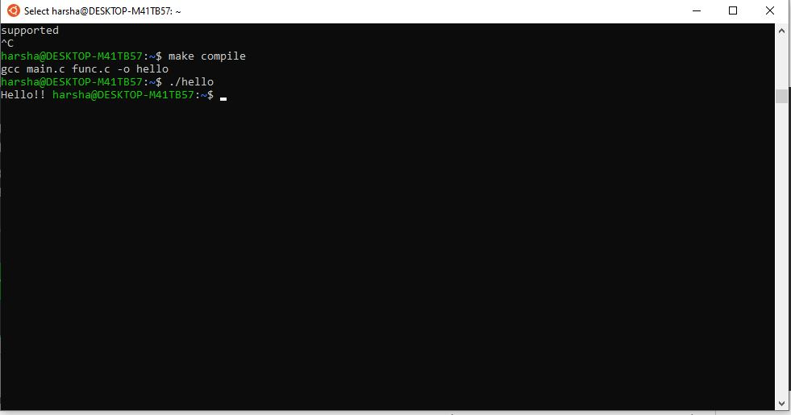

**Results:**

The make command has been successfully executed using cygwin.

**Ex: 2** Maintaining repositories using Version Control System

**Date : 26.08.2020**

**Objective:**

To get familiar working with Git and Github through Git GUI.

**Requirement:**

* Git GUI.
* Google Chrome.
* Github account.

**Theory:**

**Version Control System:**

Version control systems are a category of software tools that helps record changes to files by keeping a track of modifications done to the code.

**Use of Version Control System:**

* **A repository:** It can be thought as a database of changes. It contains all the edits and historical versions (snapshots) of the project.
* **Copy of Work (sometimes called as checkout):** It is the personal copy of all the files in a project. You can edit to this copy, without affecting the work of others and you can finally commit your changes to a repository when you are done making your changes.

**Purpose of Version Control:**

* Multiple people can work simultaneously on a single project. Everyone works on and edits their own copy of the files and it is up to them when they wish to share the changes made by them with the rest of the team.
* It also enables one person to use multiple computers to work on a project, so it is valuable even if you are working by yourself.
* It integrates the work that is done simultaneously by different members of the team. In some rare case, when conflicting edits are made by two people to the same line of a file, then human assistance is requested by the version control system in deciding what should be done.
* Version control provides access to the historical versions of a project. This is insurance against computer crashes or data loss. If any mistake is made, you can easily roll back to a previous version. It is also possible to undo specific edits that too without losing the work done in the meanwhile. It can be easily known when, why, and by whom any part of a file was edited.

**GIT:**

Git is a free and open source distributed version control system designed to handle everything from small to very large projects with speed and efficiency. Git is easy to learn and has a tiny footprint with lightning fast performance .

**Procedure and implementation:**

* The first two things you'll want to do are install git and create a free GitHub account.
* Install Git
* First, you need to install on windows; to do so, follow the below steps.
* Download and install the latest version of <https://github.com/git-forwindows/git/releases/download/v2.28.0.windows.1/Git-2.28.0-64-bit.exe>
* Use the default options for each step in the installation
* Remove Git Bash Desktop Icon
* Go to Start -> All Programs -> Git -> Git GUI and make a Desktop Shortcut.
* Now click on Show SSH Key under the Help Menu.
* It's possible that there is already a SSH key on your computer; it's best to remove or backup the key if you do not know where it came from.
* To do so, simply remove all files within: C:\Users\\.ssh. Be sure to replace with your Windows username. You can generate a SSH key by clicking on the Generate Key button.
* When you do so, you will need to supply a passphrase for security purposes. Remember this passphrase; you will need to use it later.

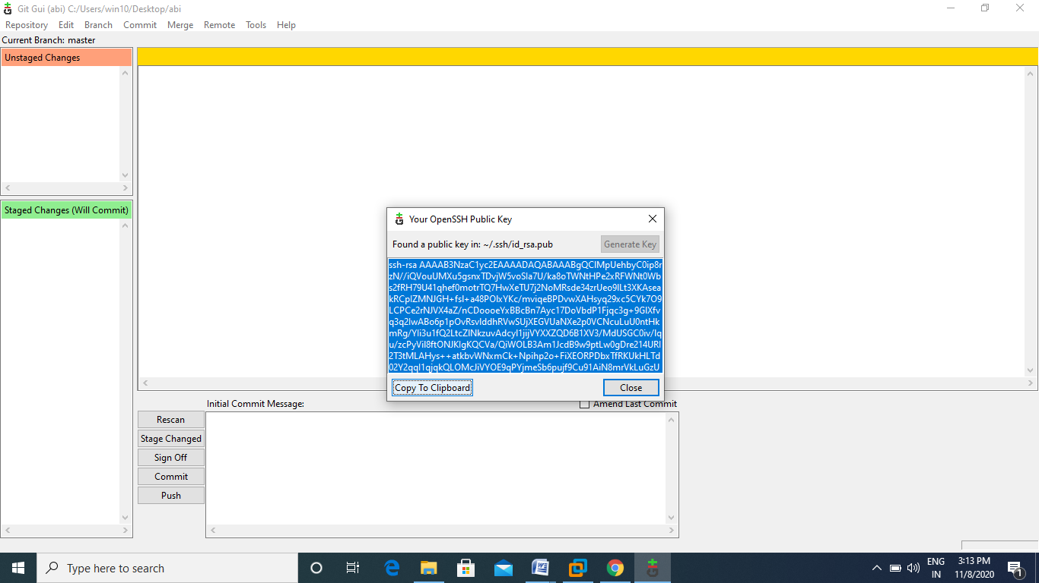

* click the "Copy to Clipboard" button.
* Next, you need to provide your hosted repo service with your public SSH key. Similar to Github, most of these sites usually have a tab, called "SSH Keys". Click the tab and add your SSH key to the website.

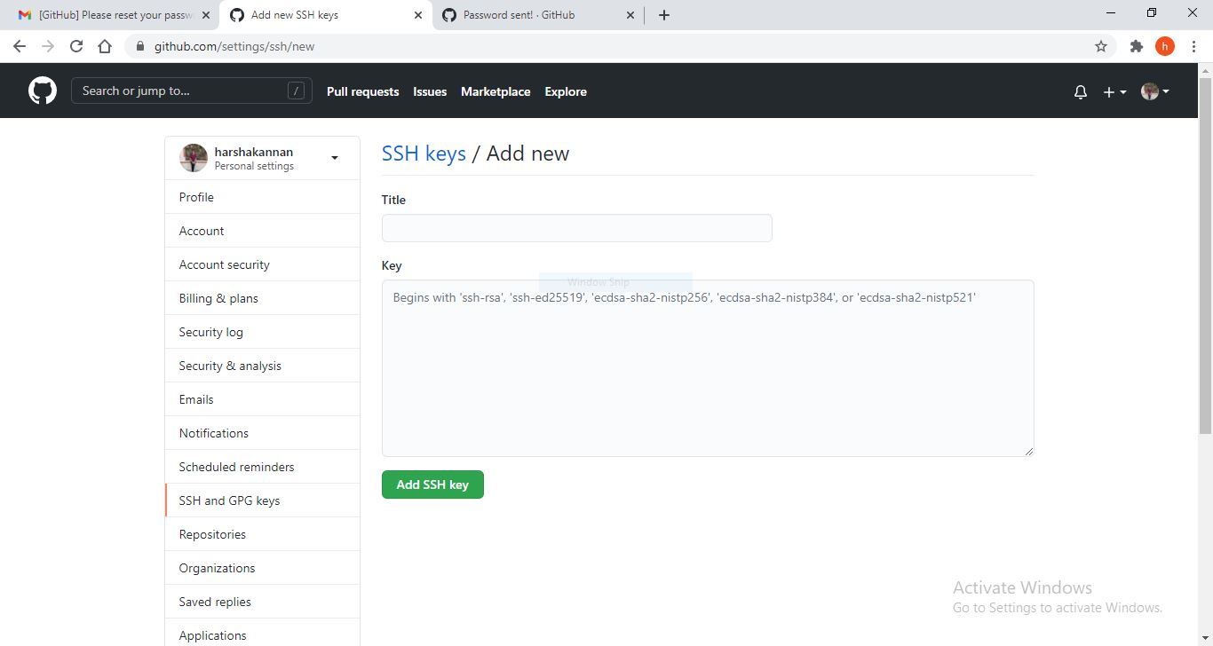

* create new remote repository on Github

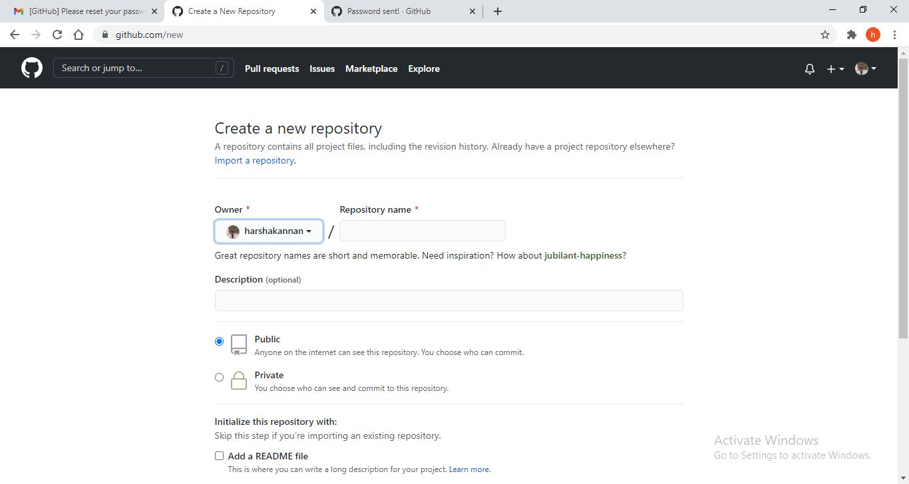

* Create a Local Repository In the Git GUI; clicking on "Create New Repository".

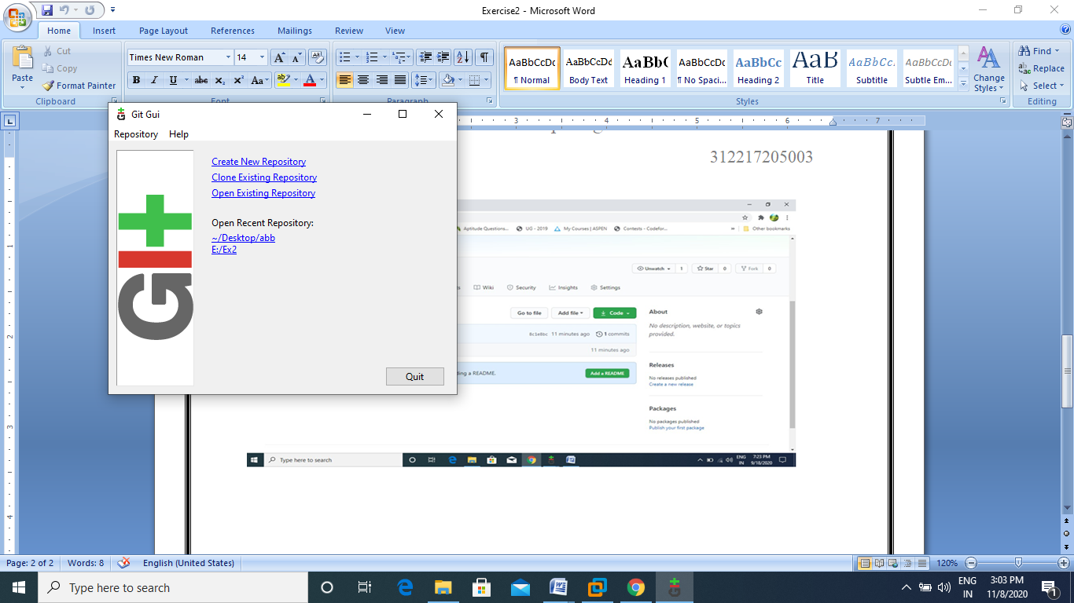

* Create new repository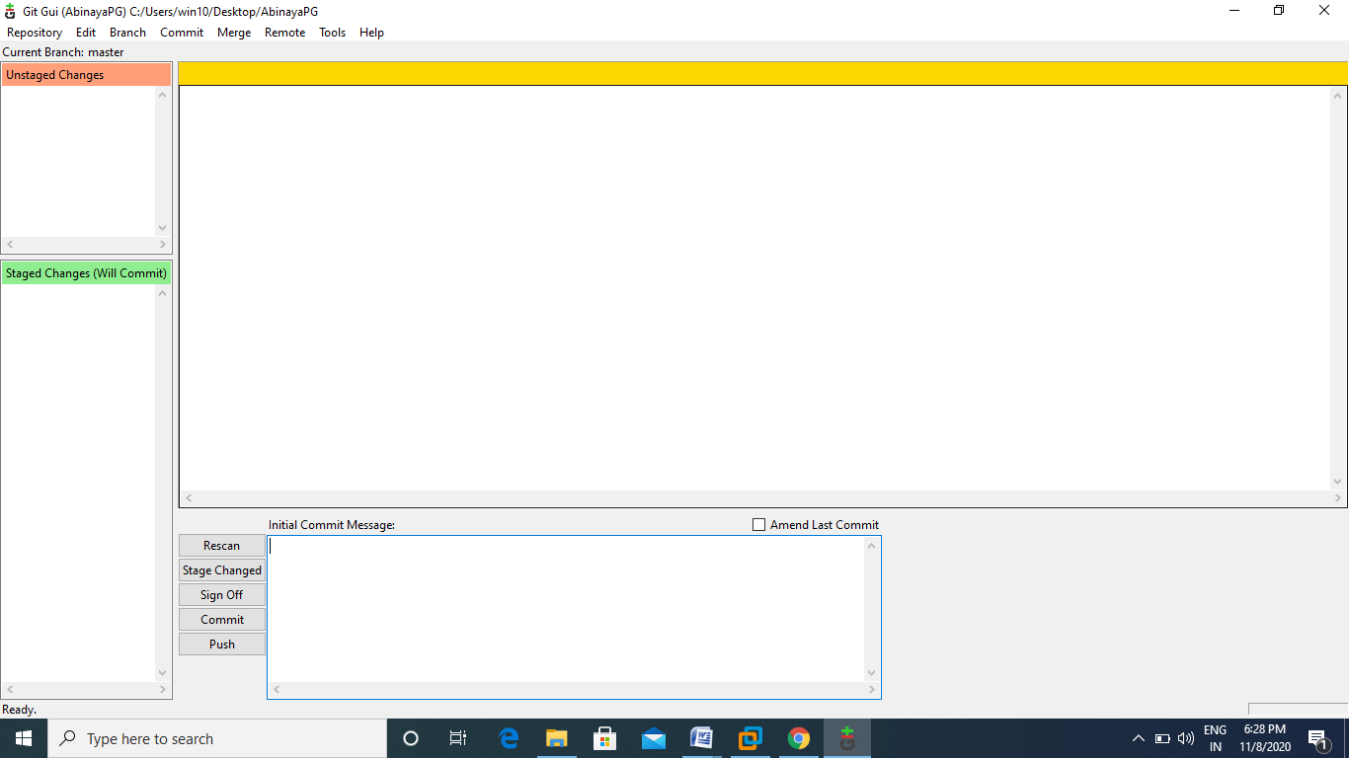
* Add a file in that folder.

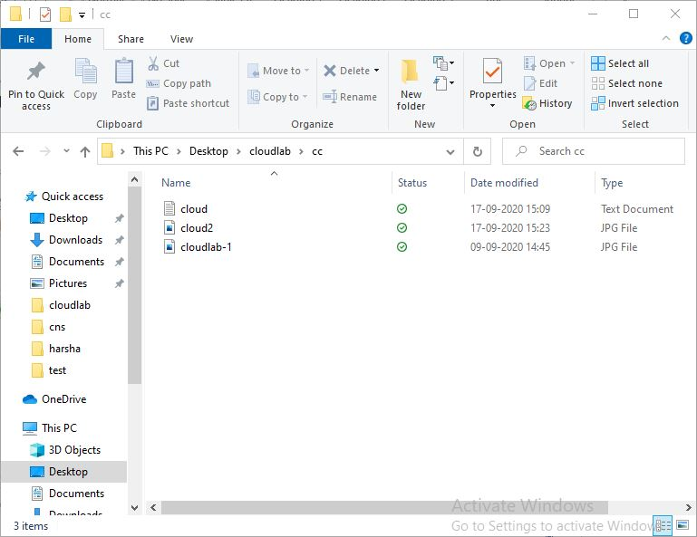

* Click rescan.

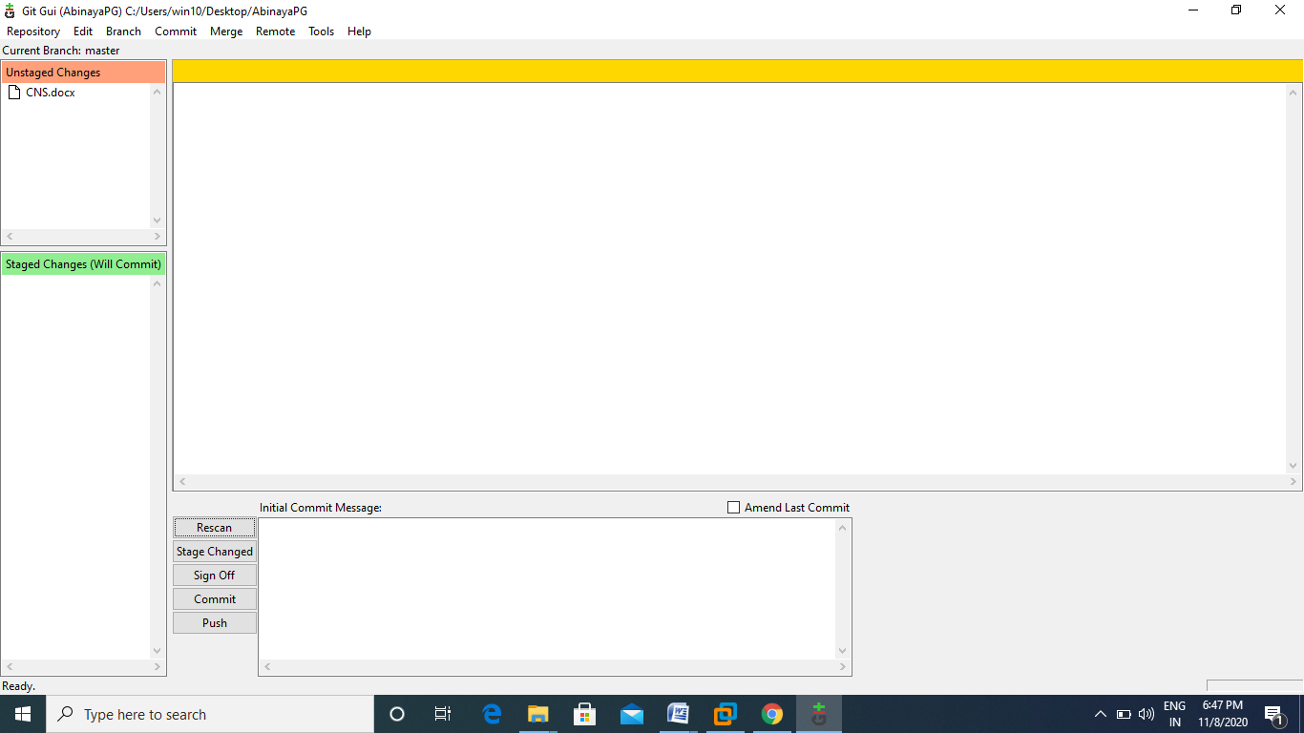

* Click Stage Changed.

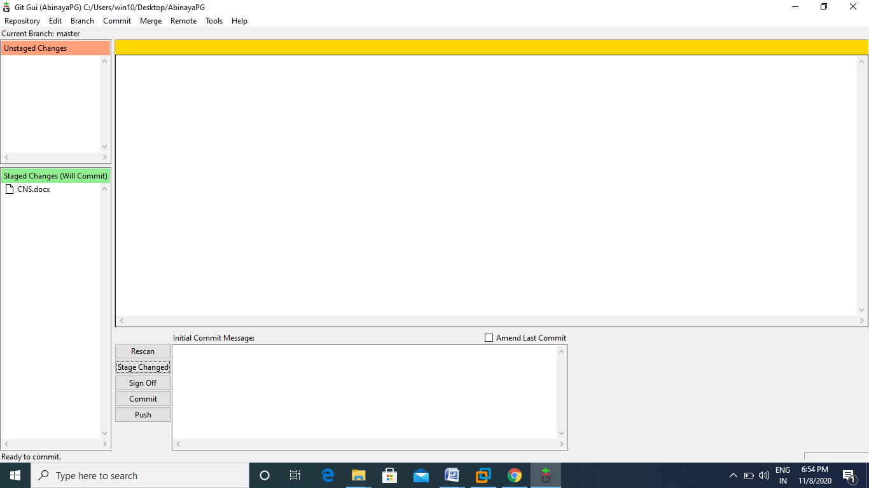

* Type message and click commit.

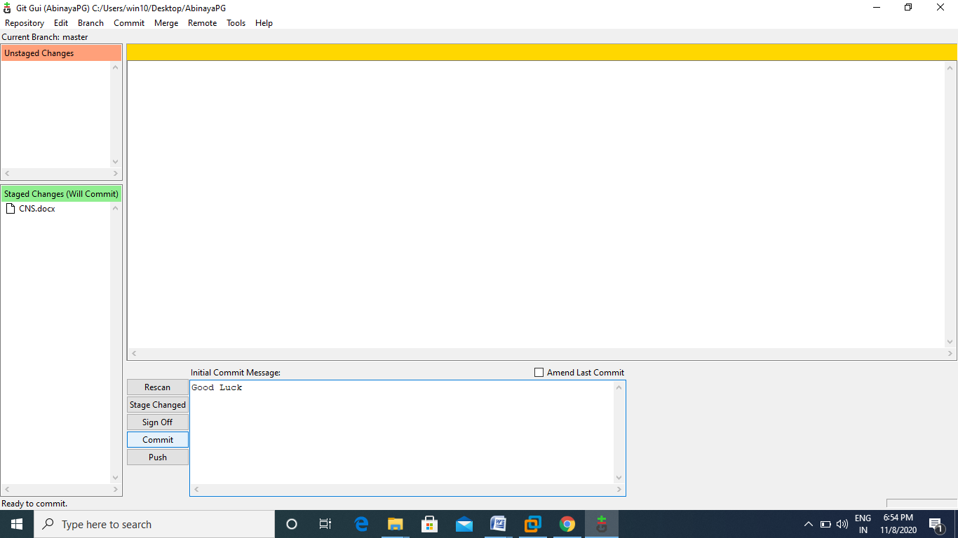

* Click Push and add arbitrary location as github repositary link.

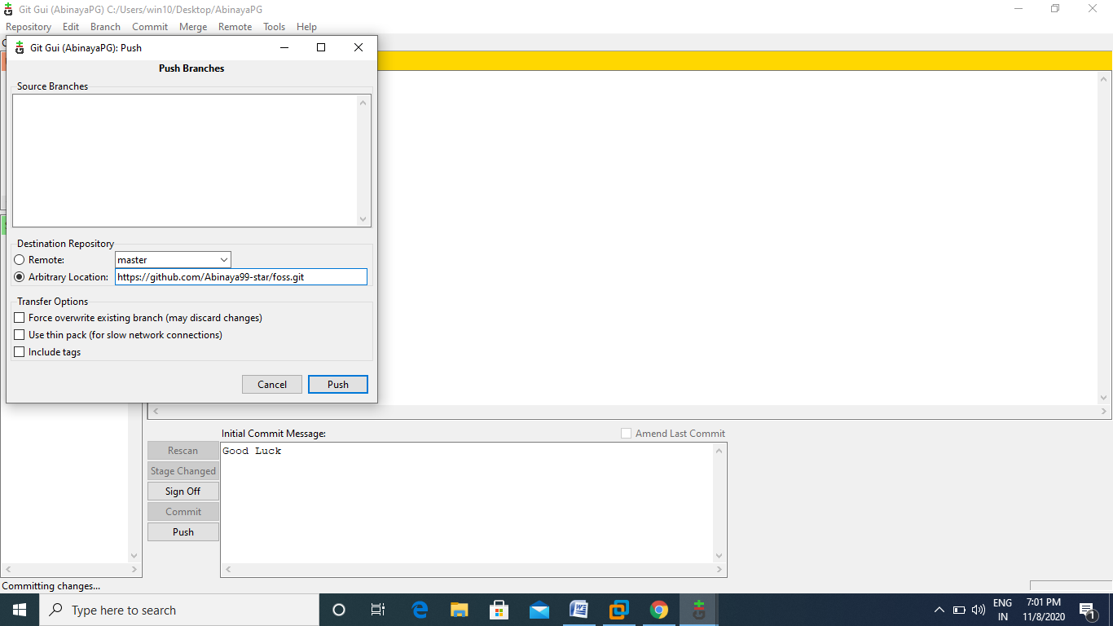

* Now the files are copied to github repository.

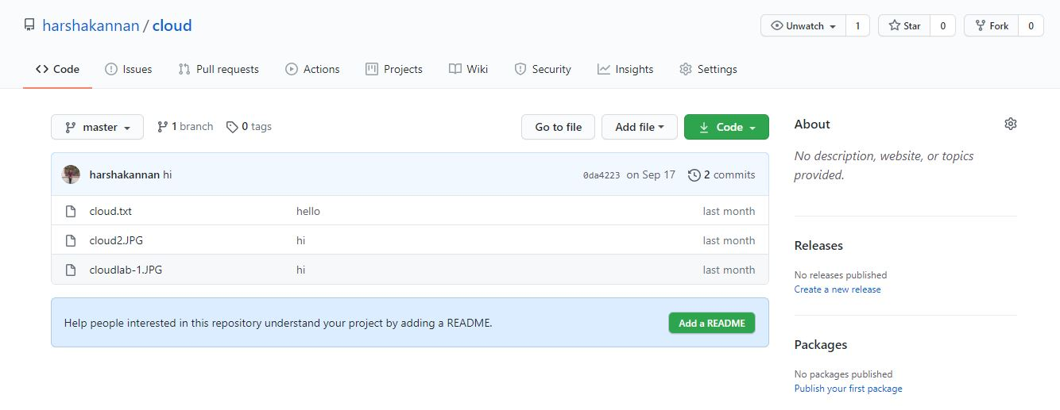

**Results:**

Thus creating and maintaining repositories using Version control system has been successfully done.

**Ex: 3 Virtualbox /VMware Workstation**

**Date : 02.09.2020**

**Objective:**

To understand the working of WMware Workstation and to understand the installation procedure and creation of VMs.

**Requirement:**

* Google Chrome (or) Related Internet Explorer.
* Ubuntu iso file.

**Theory:**

**Architecture:**

VMware Workstation virtualizes I/O devices using a novel design called the Hosted Virtual Machine Architecture. The primary feature of this design is that it takes advantage of a pre-existing operating system for I/O device support and still achieves near native performance for CPU-intensive workloads.

VMware Workstation installs like a normal application on an operating system, known as the host operating system. When run, the application portion (**VMApp**) uses a driver loaded into the host operating system (**VMDriver**) to establish the privileged virtual machine monitor component (**VMM**) that runs directly on the hardware. From then on, a given physical processor is executing either the host world or the VMM world, with the VMDriver facilitating the transfer of control between the two worlds. A world switch between the VMM and the host worlds involves saving and restoring all user and system visible state on the CPU, and is thus more heavyweight than a normal process switch.

In this architecture, the CPU virtualization is handled by the VMM. A guest application or operating system performing pure computation runs just like a traditional mainframe-style virtual machine system. However, whenever the guest performs an I/O operation, the VMM will intercept it and switch to the host world rather than accessing the native hardware directly. Once in the host world, the VMApp will perform the I/O on behalf of the virtual machine through appropriate system calls. For example, an attempt by the guest to fetch sectors from its disk will become a read() issued to the host for the corresponding data. The VMM also yields control to the host OS upon receiving a hardware interrupt. The hardware interrupt is reasserted in the host world so that the host OS will process the interrupt as if it came directly from hardware.

The hosted architecture is a powerful way for a PC-based virtual machine monitor to cope with the vast array of available hardware. One of the primary purposes of an operating system is to present applications with an abstraction of the hardware that allows hardware-independent code to access the underlying devices. For example, a program to play audio CD-ROMs will work on both IDE and SCSI CD-ROM drives because operating systems provide an abstract CD-ROM interface. VMware Workstation takes advantage of this generality to run on whole classes of hardware without itself needing special device drivers for each possible device.

The most significant trade-off of a hosted architecture is in potential I/O performance degradation. Because I/O emulation is done in the host world, a virtual machine executing an I/O intensive workload can accrue extra CPU time switching between the VMM and host worlds, as well as significant time in the host world performing I/O to the native hardware. This increases the CPU overhead associated with any I/O operation.

Another trade-off of the hosted architecture is that the host OS is in full control of machine resources. Even though the VMM has full system and hardware privileges, it behaves cooperatively and allows the host OS to schedule it. The host OS can also page out the memory allocated to a particular virtual machine except for a small set of pages that the VMM has pinned on behalf of the virtual machine. This allows VMware Workstation to be treated by the host OS like a regular application, but occasionally at the expense of performance if the host OS makes poor resource scheduling choices for the virtual machine.

**Procedure and implementation:**

* Go to https://www.vmware.com/in/products/workstation-pro/workstation-pro-evaluation.html

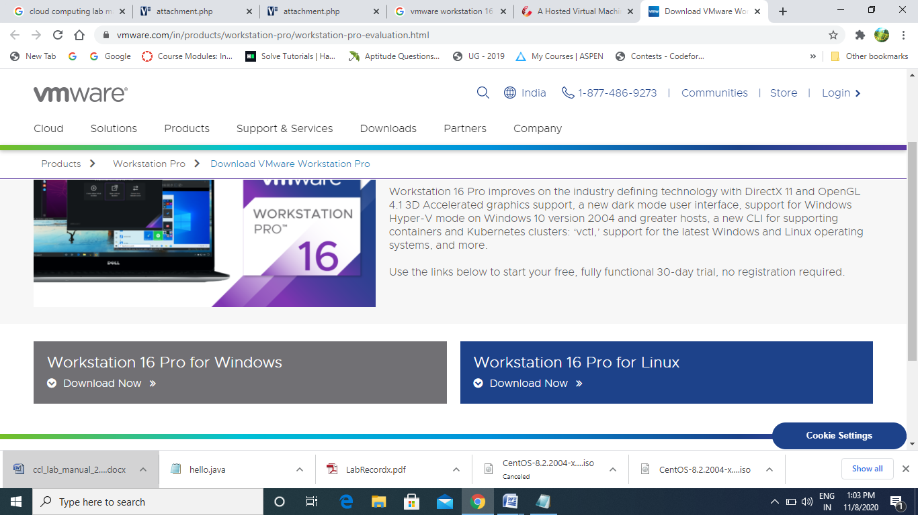

* Download workstation 16 Pro for Windows.
* Once downloaded install it.

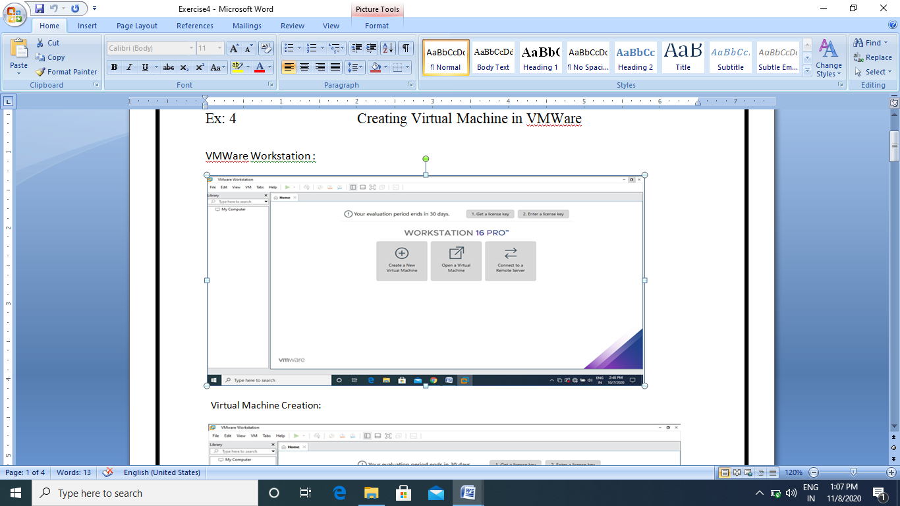

* Create a new Virtual Machine and use ubuntu iso file for creation of ubuntu VM.

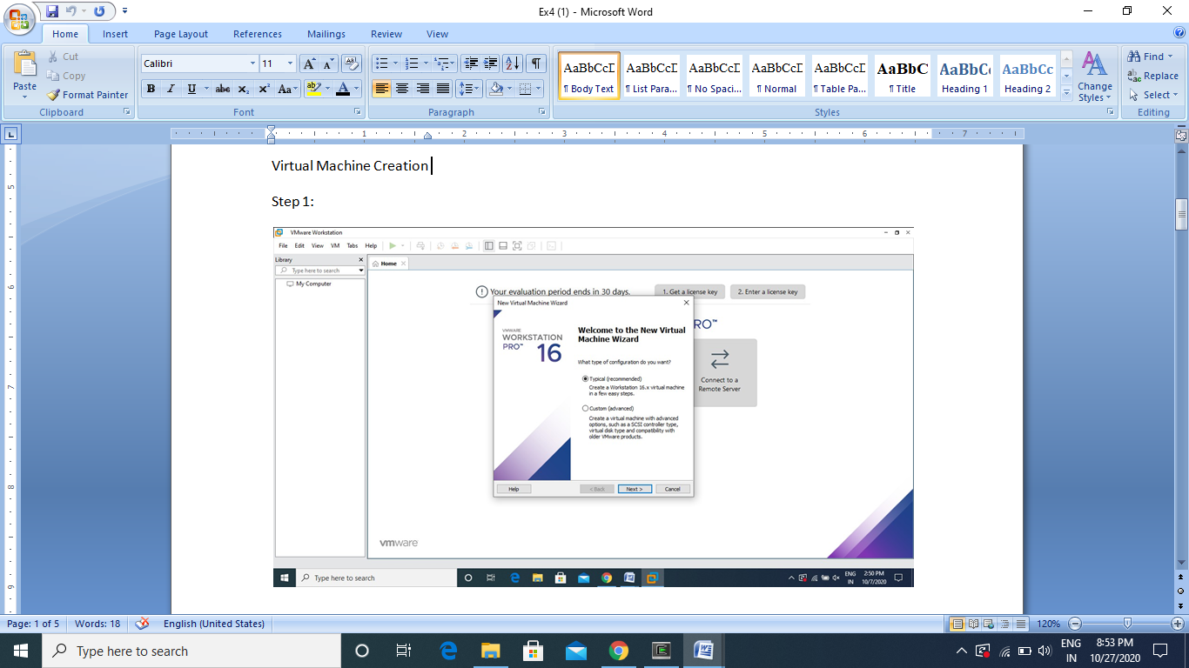

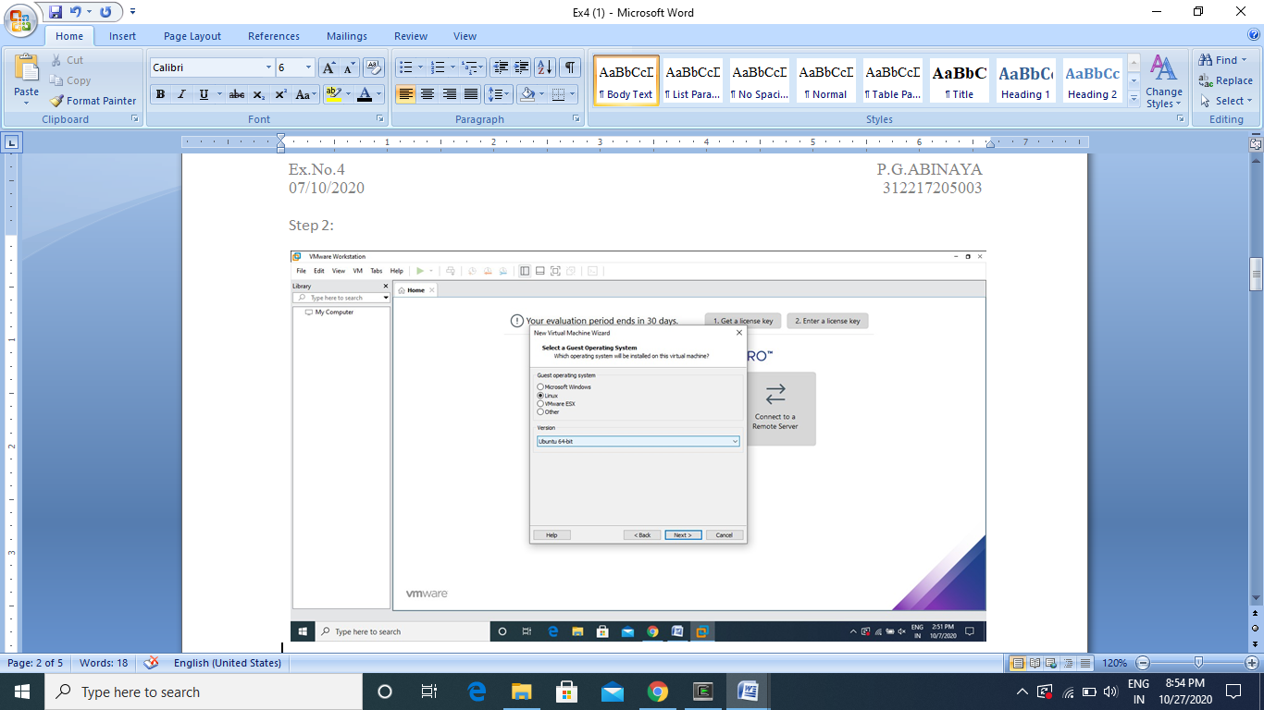

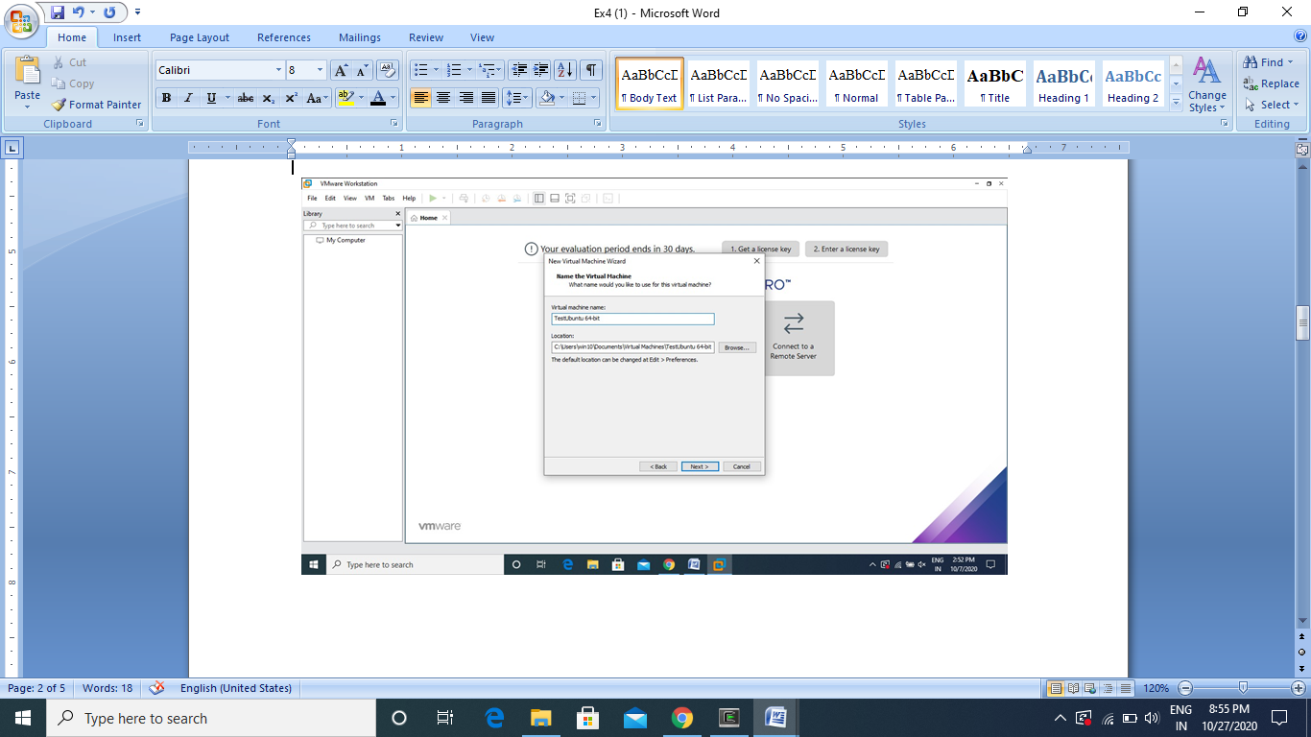

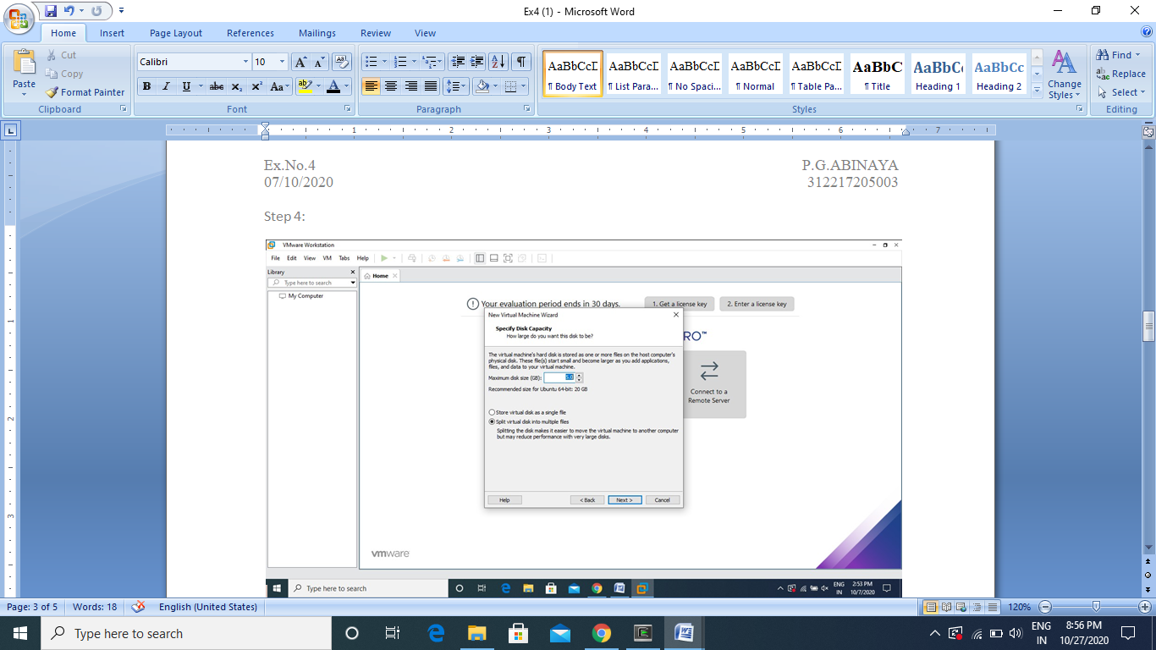

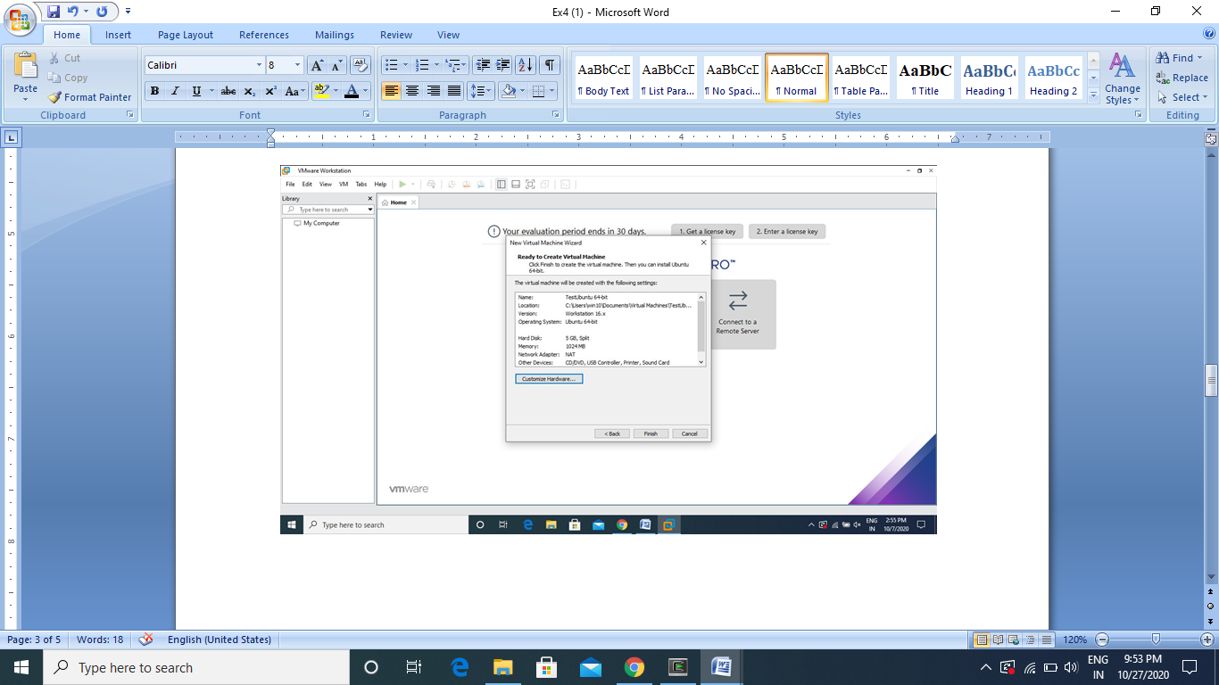

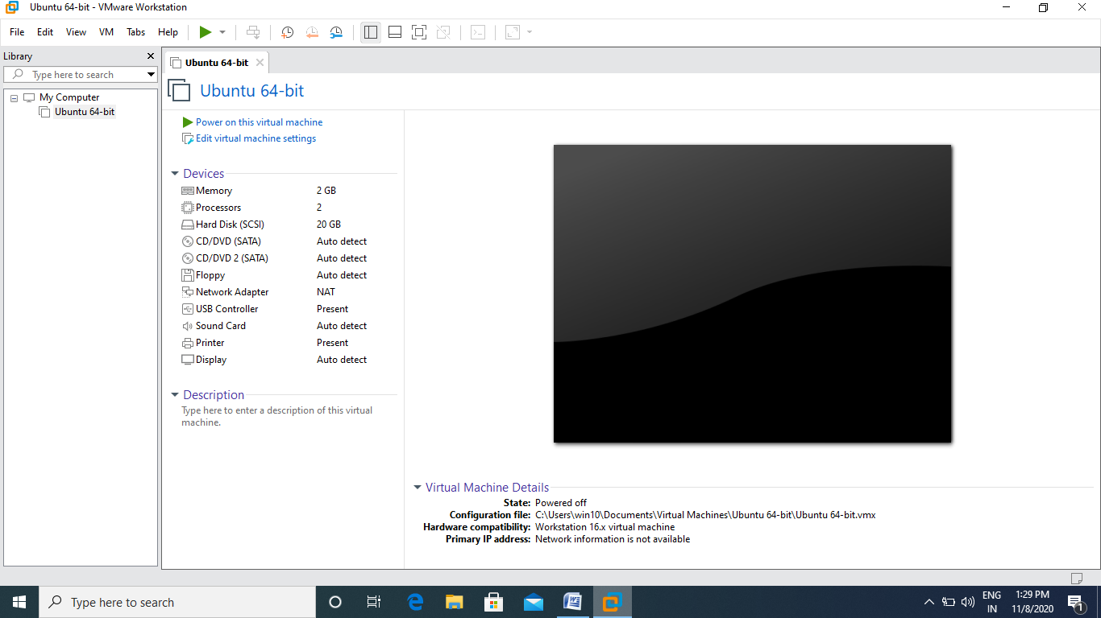

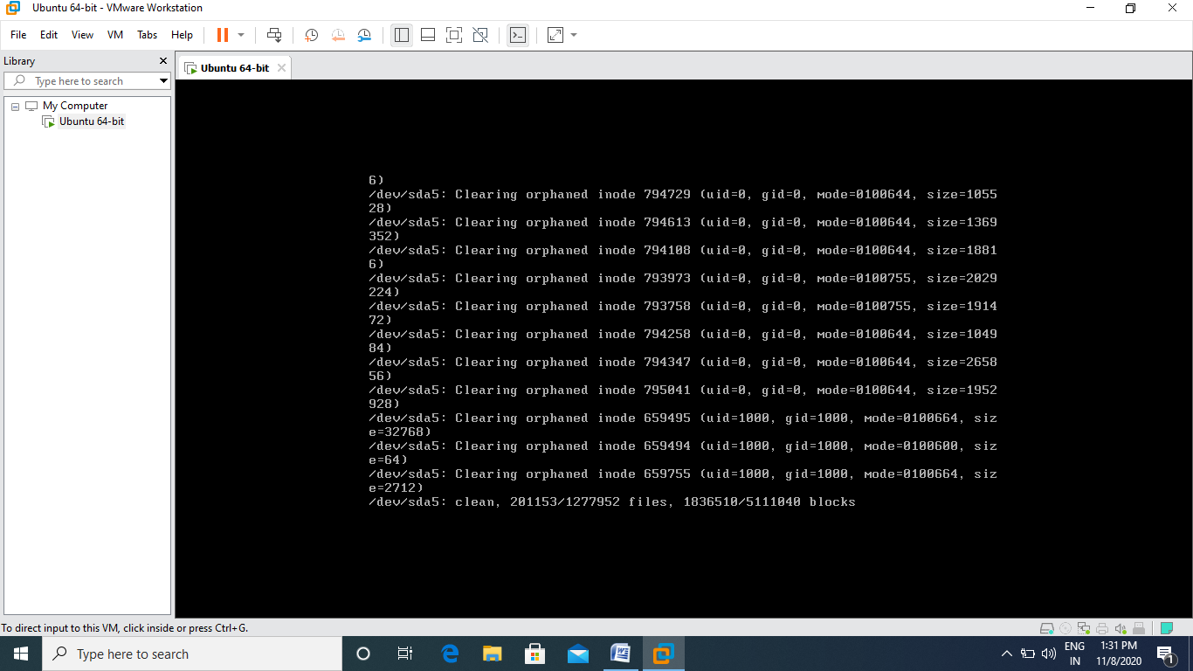

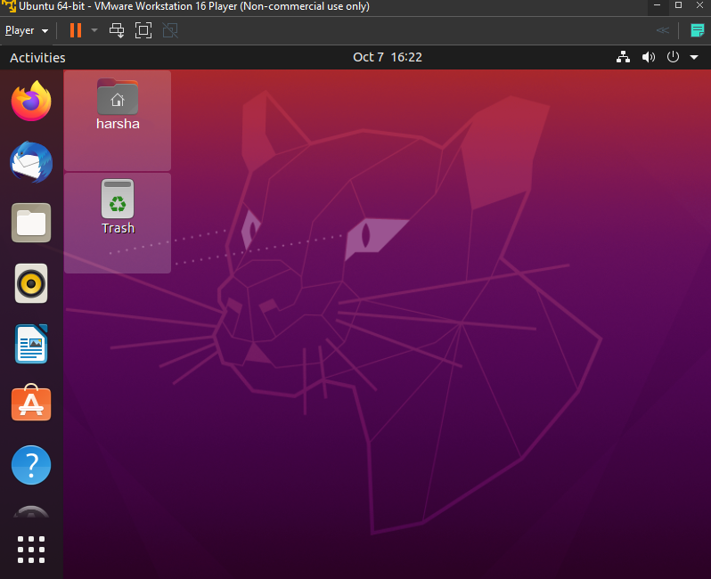

**Results:**

The VMware workstation 16 Pro has been successfully installed and Ubuntu VM has been successfully created.

**Ex: 4 Programming with VMs**

**Date : 09.09.2020**

**Objective:**

To understand the installation procedure of GCC and to program with VMs.

**Requirement:**

* VMware workstation 16 Pro,
* Ubuntu OS.

**Theory:**

**Virtual Machine:**

With the introduction of new technologies and newer research models, a lot number of hardware and software products are being launched. Many of the software are platform-dependent hence it is sometimes difficult to debug or check them because of the limited hardware resources.A VM (virtual machine) is an emulation of a computer system, where these machines use computer architectures to provide the functionality of a physical computer.  The physical device on which virtual machines work is known as Host, whereas the virtual machines are known as Guest. A single host can have multiple numbers of guests.

**Procedure and implementation:**

* Open Ubuntu VM in VMware workstation Pro.



* Install gcc using the following command.

*sudo apt install gcc*

* Create hello.c file.
* Compile and Run the hello.c file.

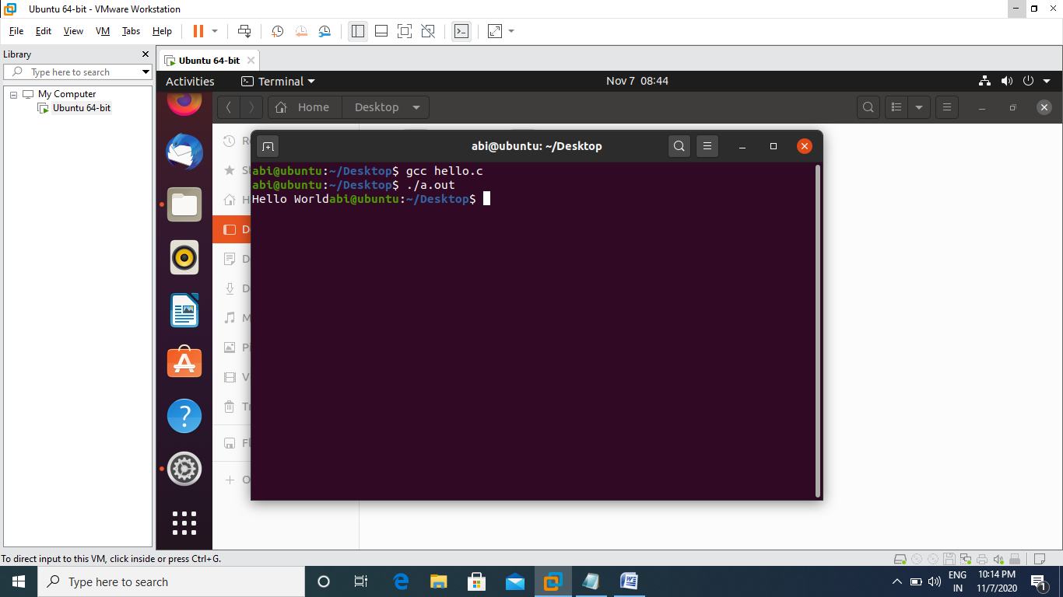

**Results:**

GCC has been successfully installed and the above program has been successfully executed in Ubuntu Virtual Machine in VMware workstation 16 Pro.

**Ex: 5 Google App Engine installation**

**Date : 16.09.2020**

**Objective:**

To understand the working of Google App Engine and to learn the installation procedure of Google App Engine.

**Requirement:**

* Google Chrome (or) related internet explorer
* JRE 11 (or) higher

**Theory:**

**Architecture:**

The Google App Engine (GAE) is Google`s answer to the ongoing trend of Cloud Computing offerings within the industry. In the traditional sense, GAE is a web application hosting service, allowing for development and deployment of web-based applications within a predefined runtime environment. Unlike other cloud-based hosting offerings such as Amazon Web Services that operate on an IaaS level, the GAE already provides an application infrastructure on the PaaS level. This means that the GAE abstracts from the underlying hardware and operating system layers by providing the hosted application with a set of application-oriented services. While this approach is very convenient for developers of such applications, the rationale behind the GAE is its focus on scalability and usage-based infrastructure as well as payment.

**Costs:**

Developing and deploying applications for the GAE is generally free of charge but restricted to a certain amount of traffic generated by the deployed application. Once this limit is reached within a certain time period, the application stops working. However, this limit can be waived when switching to a billable quota where the developer can enter a maximum budget that can be spent on an application per day. Depending on the traffic, once the free quota is reached the application will continue to work until the maximum budget for this day is reached. Table 1 summarizes some of the in our opinion most important quotas and corresponding amount per unit that is charged when free resources are depleted and additional, billable quota is desired.

**Features:**

With a Runtime Environment, the Data store and the App Engine services, the GAE can be divided into three parts. Runtime Environment The GAE runtime environment presents itself as the place where the actual application is executed. However, the application is only invoked once an HTTP request is processed to the GAE via a web browser or some other interface, meaning that the application is not constantly running if no invocation or processing has been done. In case of such an HTTP request, the request handler forwards the request and the GAE selects one out of many possible Google servers where the application is then instantly deployed and executed for a certain amount of time (8). The application may then do some computing and return the result back to the GAE request handler which forwards an HTTP response to the client. It is important to understand that the application runs completely embedded in this described sandbox environment but only as long as requests are still coming in or some processing is done within the application. The reason for this is simple: Applications should only run when they are actually computing, otherwise they would allocate precious computing power and memory without need. This paradigm shows already the GAE‘s potential in terms of scalability. Being able to run multiple instances of one application independently on different servers guarantees for a decent level of scalability. However, this highly flexible and stateless application execution paradigm has its limitations. Requests are processed no longer than 30 seconds after which the response has to be returned to the client and the application is removed from the runtime environment again (8). Obviously this method accepts that for deploying and starting an application each time a request is processed, an additional lead time is needed until the application is finally up and running. The GAE tries to encounter this problem by caching the application in the server memory as long as possible, optimizing for several subsequent requests to the same application. The type of runtime environment on the Google servers is dependent on the programming language used. For Java or other languages that have support for Java-based compilers (such as JRuby, Rhino and Groovy) a Java-based Java Virtual Machine (JVM) is provided. Also, GAE fully supports the Google Web Toolkit (GWT), a framework for rich web applications. For Python and related frameworks a Python-based environment is used.

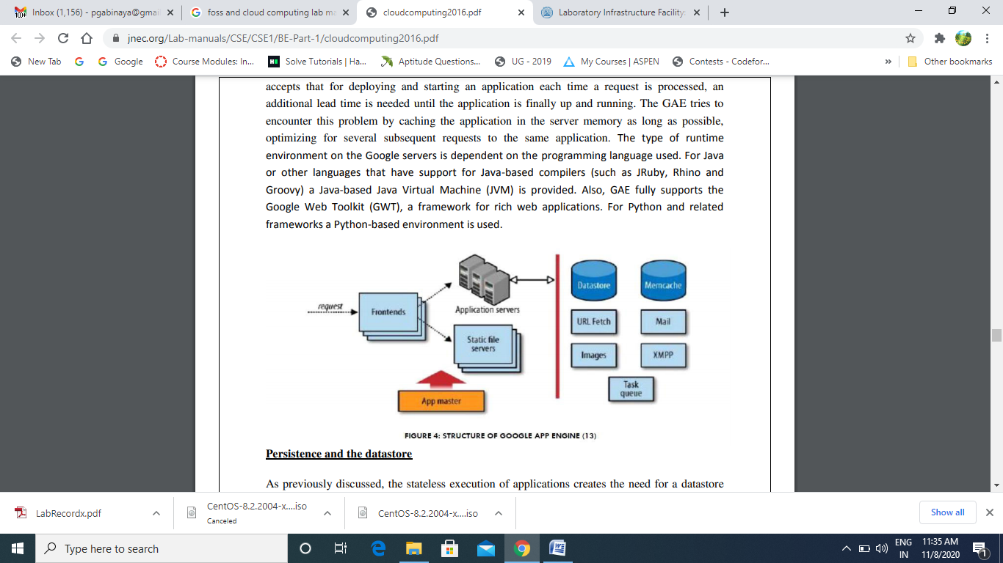

**Procedure and implementation:**

* Go to <https://cloud.google.com/appengine/downloads> and select java as standard environment.

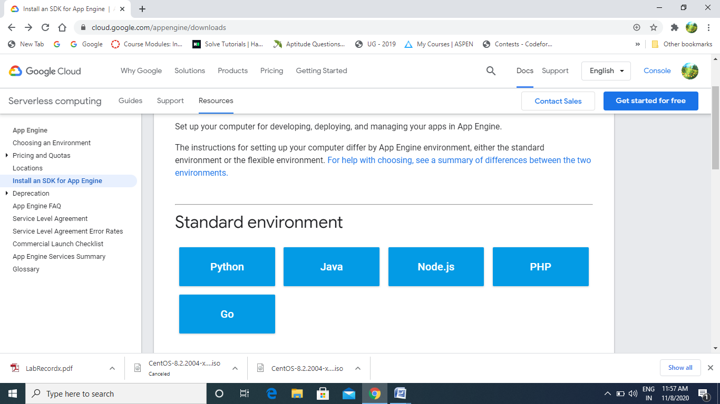

* Install and Initialize the cloud SDK.

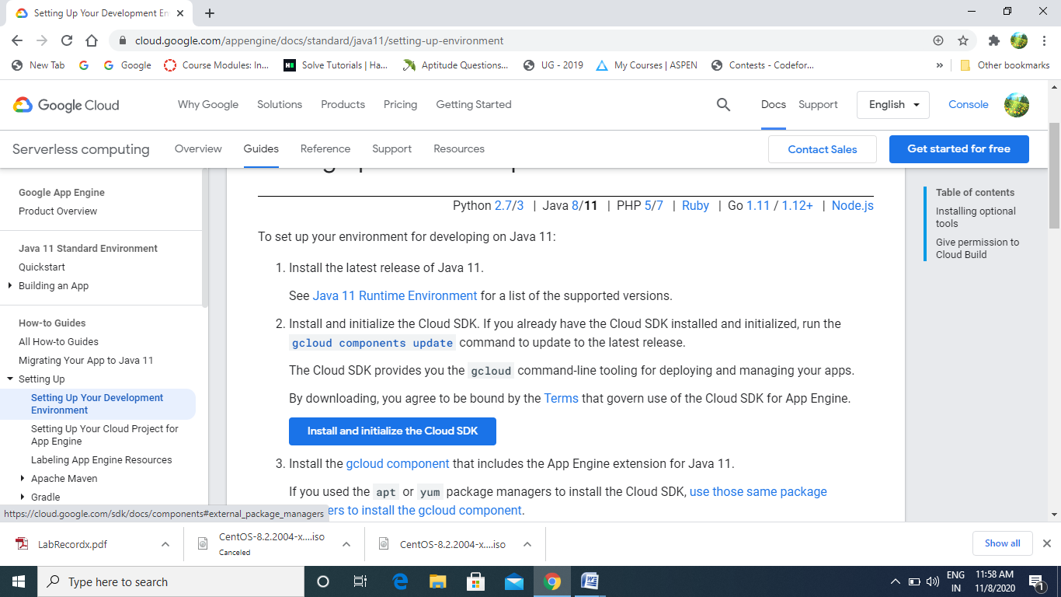

* The google cloud SDK shell will be opened as soon as the installation is over.
* Use *gcloud –h* to view the list of commands.

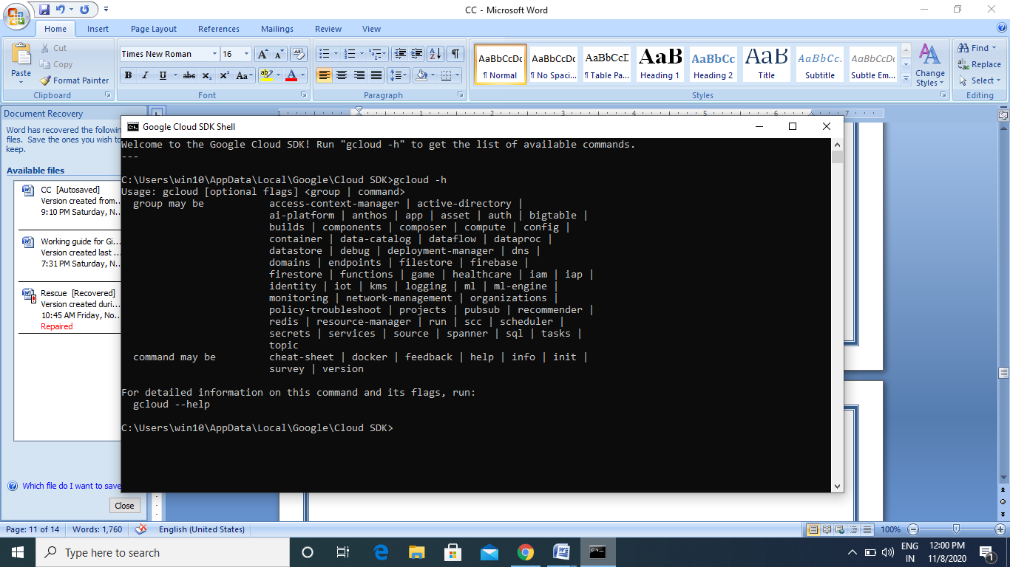

**Results:**

The Google App Engine has been successfully installed.

**Ex: 6 Build and Deploy Applications in GAE**

**Date : 23.09.2020**

**Objective:**

To understand and work with building and deployment of Applications in Google App Engine.

**Requirement:**

Google App Engine

**Theory:**

**APPLICATION DEVELOPMENT USING GOOGLE APP ENGINE:**

General Idea In order to evaluate the flexibility and scalability of the GAE we tried to come up with an application that relies heavily on scalability, i.e. collects large amounts of data from external sources. That way we hoped to be able to test both persistency and the gathering of data from external sources at large scale. Therefore our idea has been to develop an application that connects people`s delicious bookmarks with their respective Facebook accounts. People using our application should be able to see what their Facebook friends‘ delicious bookmarks are, provided their Facebook friends have such a delicious account. This way a user can get a visualization of his friends‘ latest topics by looking at a generated tag cloud giving him a clue about the most common and shared interests.

**PLATFORM AS A SERVICE:**

**GOOGLE APP ENGINE:**

The Google cloud, called Google App Engine, is a ‗platform as a service‘ (PaaS) offering. In contrast with the Amazon infrastructure as a service cloud, where users explicitly provision virtual machines and control them fully, including installing, compiling and running software on them, a PaaS offering hides the actual execution environment from users. Instead, a software platform is provided along with an SDK, using which users develop applications and deploy them on the cloud. The PaaS platform is responsible for executing the applications, including servicing external service requests, as well as running scheduled jobs included in the application. By making the actual execution servers transparent to the user, a PaaS platform is able to share application servers across users who need lower capacities, as well as automatically scale resources allocated to applications that experience heavy loads. Below Figure depicts a user view of Google App Engine. Users upload code, in either Java or Python, along with related files, which are stored on the Google File System, a very large scale fault tolerant and redundant storage system. It is important to note that an application is immediately available on the internet as soon as it is successfully uploaded (no virtual servers need to be explicitly provisioned as in IaaS).

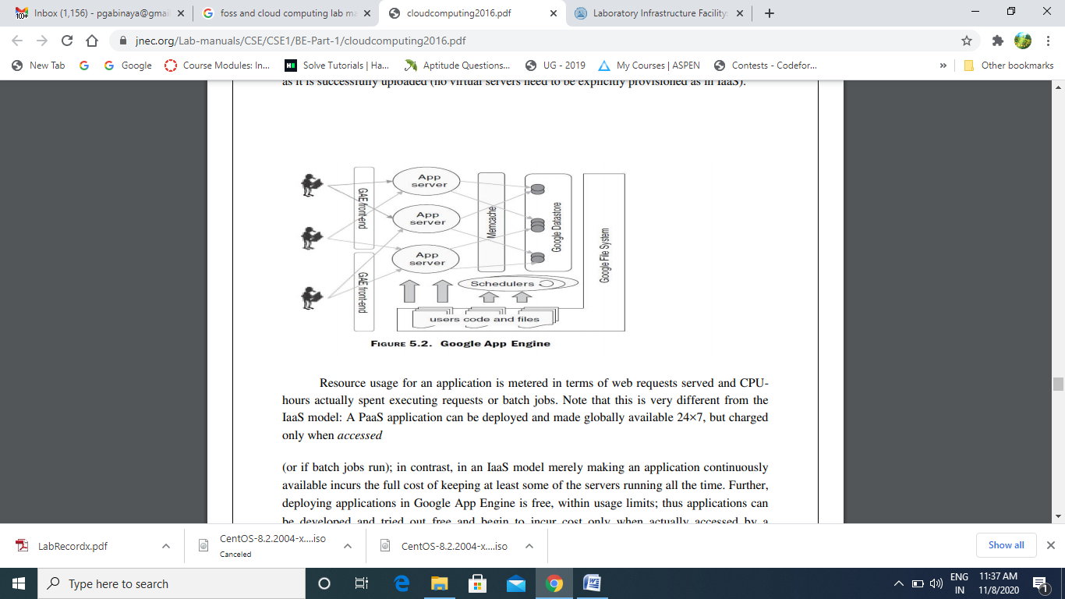

Resource usage for an application is metered in terms of web requests served and CPUhours actually spent executing requests or batch jobs. Note that this is very different from the IaaS model: A PaaS application can be deployed and made globally available 24×7, but charged only when accessed (or if batch jobs run); in contrast, in an IaaS model merely making an application continuously available incurs the full cost of keeping at least some of the servers running all the time. Further, deploying applications in Google App Engine is free, within usage limits; thus applications can be developed and tried out free and begin to incur cost only when actually accessed by a sufficient volume of requests. The PaaS model enables Google to provide such a free service because applications do not run in dedicated virtual machines; a deployed application that is not accessed merely consumes storage for its code and data and expends no CPU cycles. GAE applications are served by a large number of web servers in Google‘s data centers that execute requests from end-users across the globe. The web servers load code from the GFS into memory and serve these requests. Each request to a particular application is served by any one of GAE‘s web servers; there is no guarantee that the same server will serve requests to any two requests, even from the same HTTP session. Applications can also specify some functions to be executed as batch jobs which are run by a scheduler.

**Google Datastore:**

Applications persist data in the Google Datastore, which is also (like Amazon SimpleDB) a nonrelational database. The Datastore allows applications to define structured types (called ‗kinds‘) and store their instances (called ‗entities‘) in a distributed manner on the GFS file system. While one can view Datastore ‗kinds‘ as table structures and entities as records, there are important differences between a relational model and the Datastore, some of which are also illustrated in Figure.

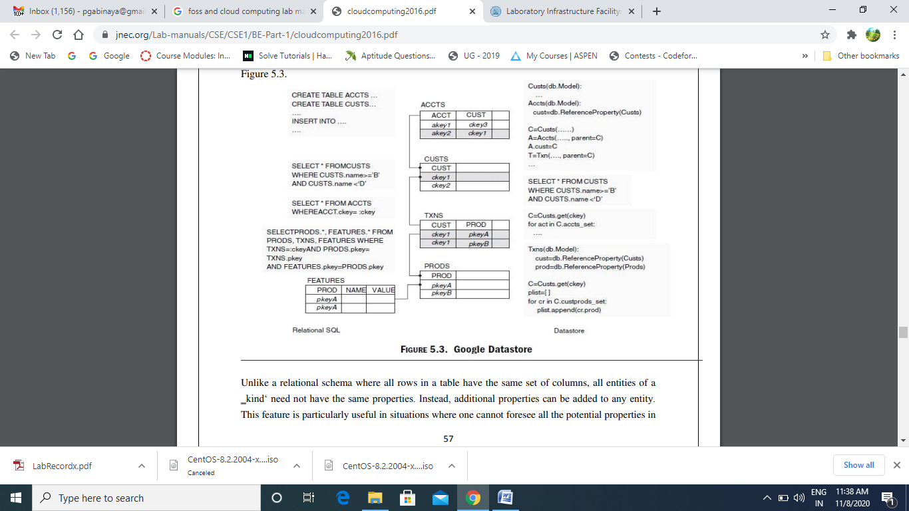

**Procedure and implementation:**

* Go to <https://cloud.google.com/appengine/docs/standard/java11/setting-up-environment> and go to console.

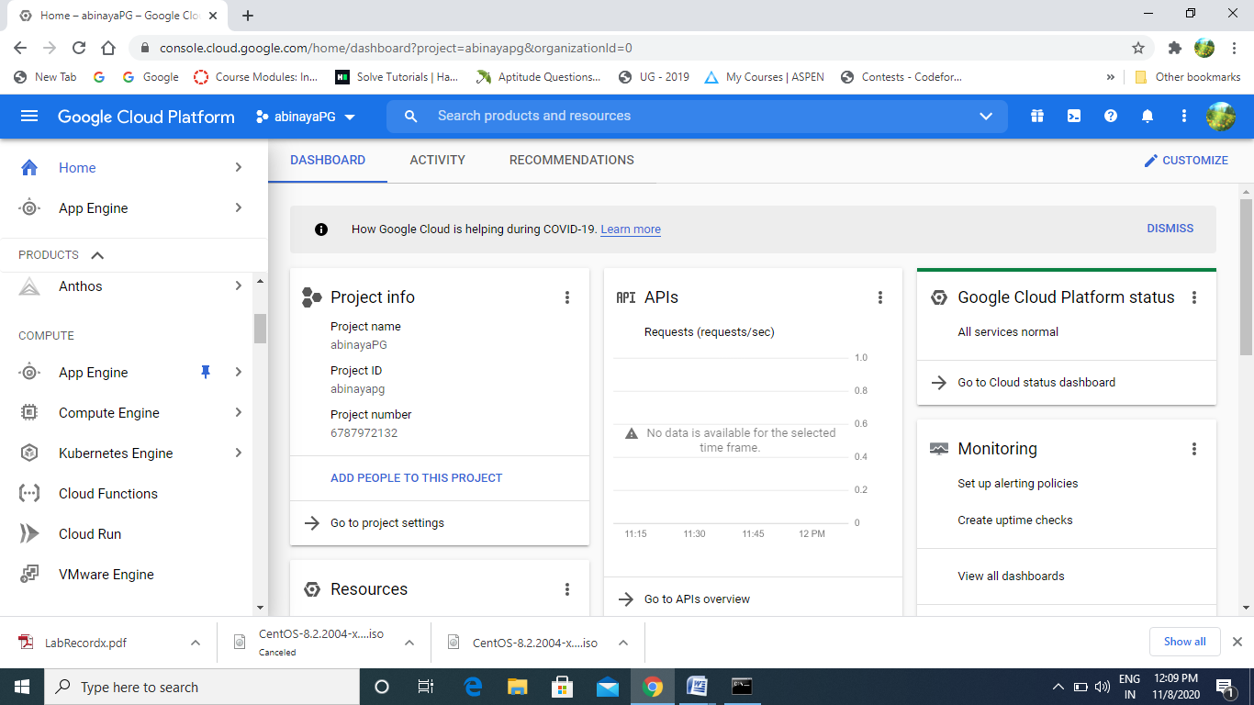

* Activate cloud shell and type the application in the editor.

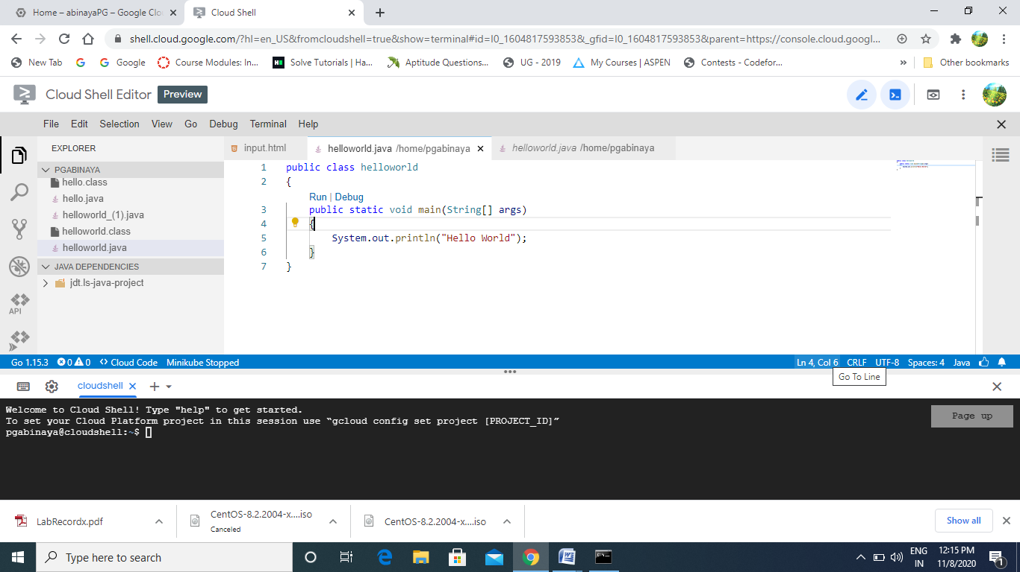

* Run/Deploy the application.

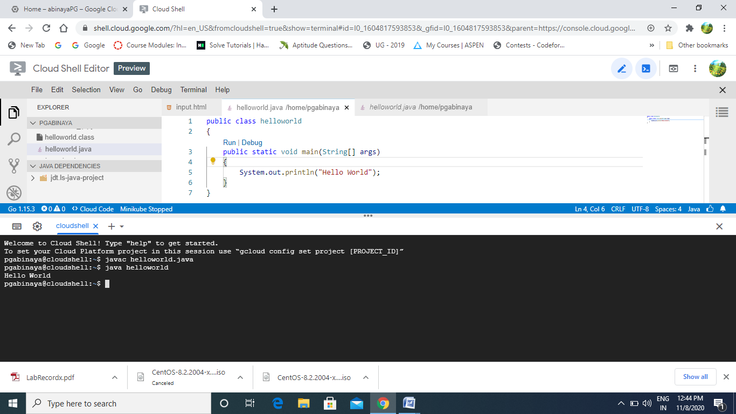

* Upload any file from Desktop to GAE.

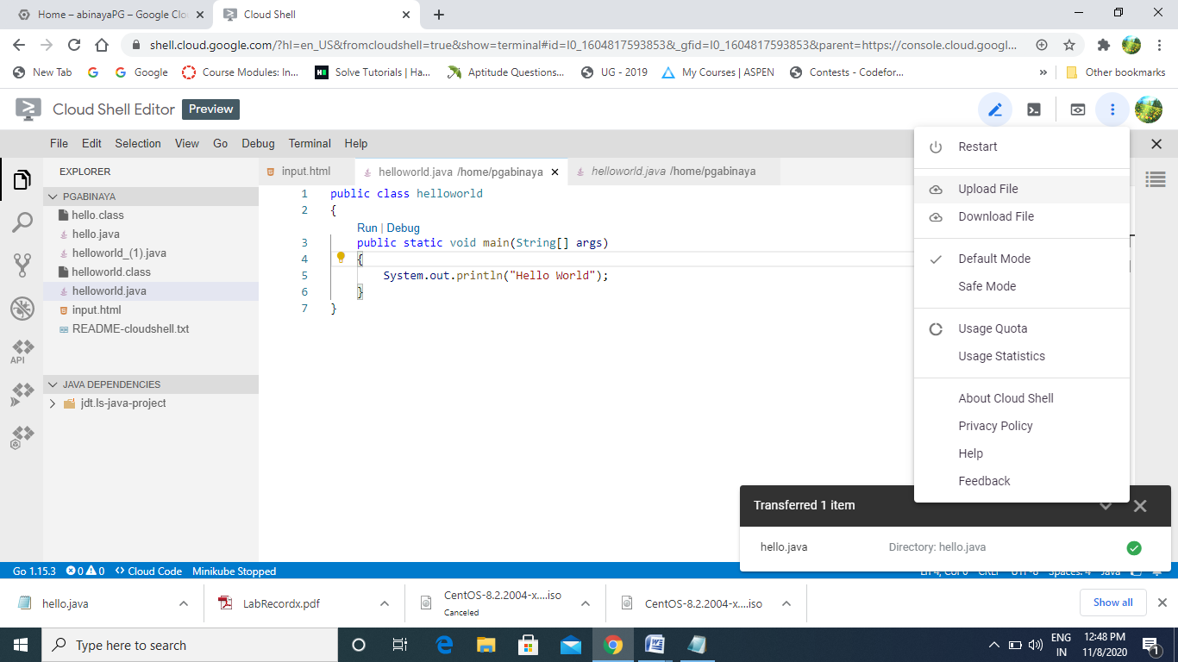

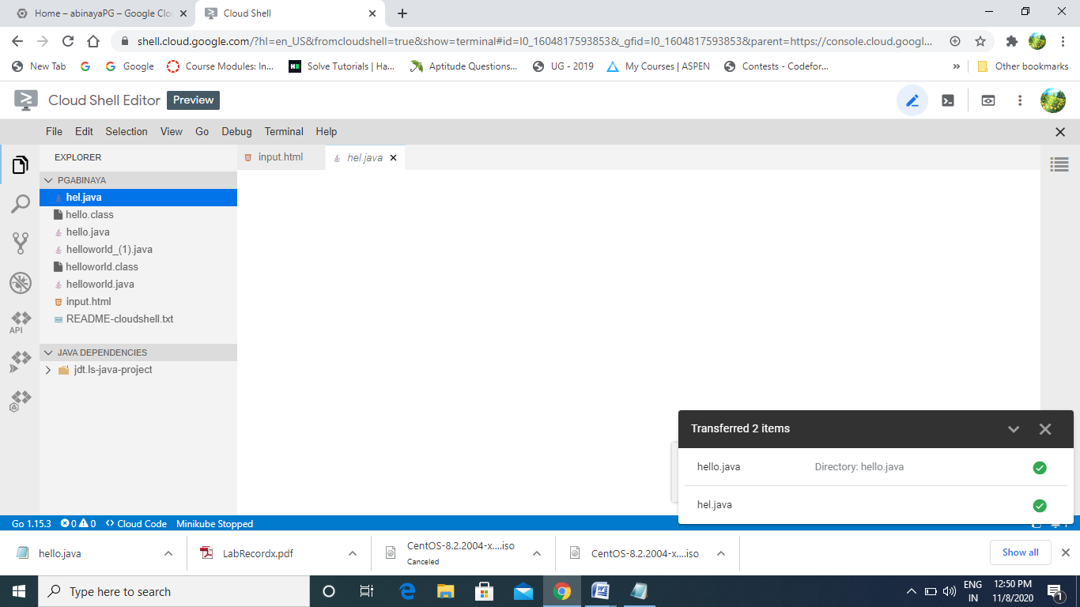

* Download the file from GAE to Desktop.

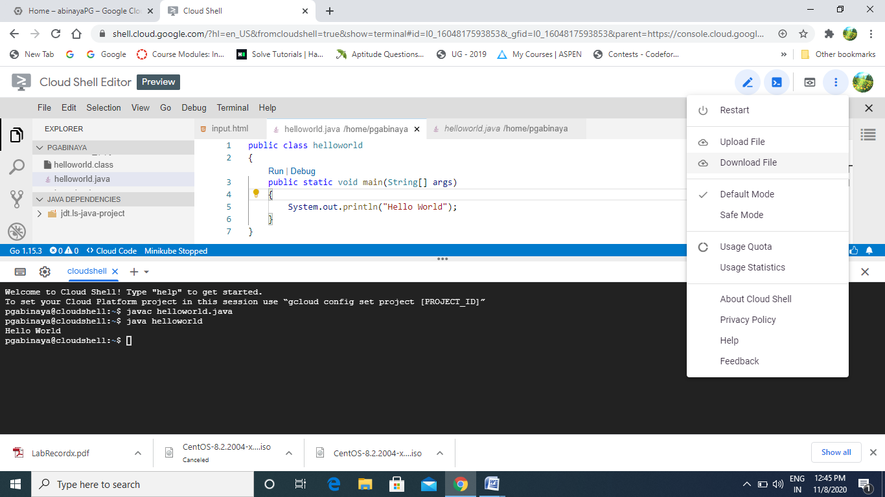

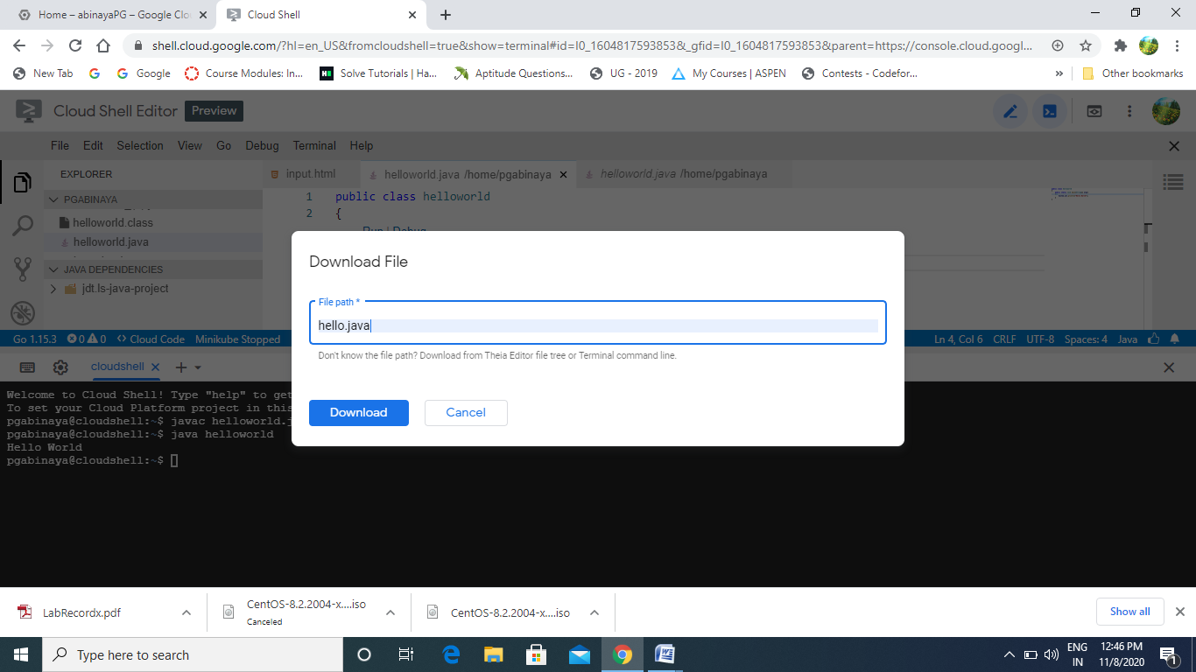

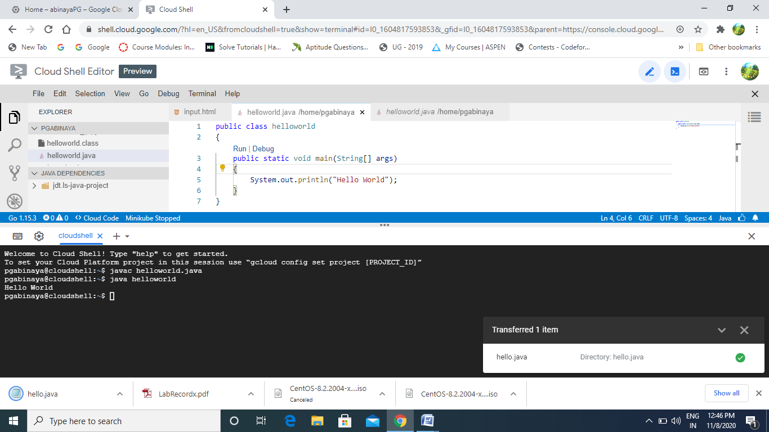

**Results:**

The above application has been successfully build and deployed in Google App Engine.

**Ex: 7 Build and run the scheduling in CloudSim**

**Date : 30.09.2020**

**Objective:**

To understand the working of cloudsim and to implement scheduling algorithm using cloudsim in eclipse.

**Requirement:**

* Eclipse (latest version)
* Cloudsim folder
* Common math folder

**Theory:**

CloudSim is a simulation toolkit that supports the modeling and simulation of the core functionality of cloud, like job/task queue, processing of events, creation of cloud entities(datacenter, datacenter brokers, etc), communication between different entities, implementation of broker policies, etc.

This toolkit allows to:

* Test application services in a repeatable and controllable environment.
* Tune the system bottlenecks before deploying apps in an actual cloud.
* Experiment with different workload mix and resource performance scenarios on simulated infrastructure for developing and testing adaptive application provisioning techniques

Core features :

* The Support of modeling and simulation of large scale computing environment as federated cloud data centers, virtualized server hosts, with customizable policies for provisioning host resources to virtual machines and energy-aware computational resources
* It is a self-contained platform for modeling cloud’s service brokers, provisioning, and allocation policies.
* It supports the simulation of network connections among simulated system elements.
* Support for simulation of federated cloud environment, that inter-networks resources from both private and public domains.
* Availability of a virtualization engine that aids in the creation and management of multiple independent and co-hosted virtual services on a data center node.
* Flexibility to switch between space shared and time shared allocation of processing cores to virtualized services.

**Procedure and implementation:**

* Create a folder and paste the cloudsim and common math folder in that.
* Open eclipse.
* File->New->java project.
* Browse cloudsim folder and click finish
* Create Simulation.java and update DataCenterBroker.java

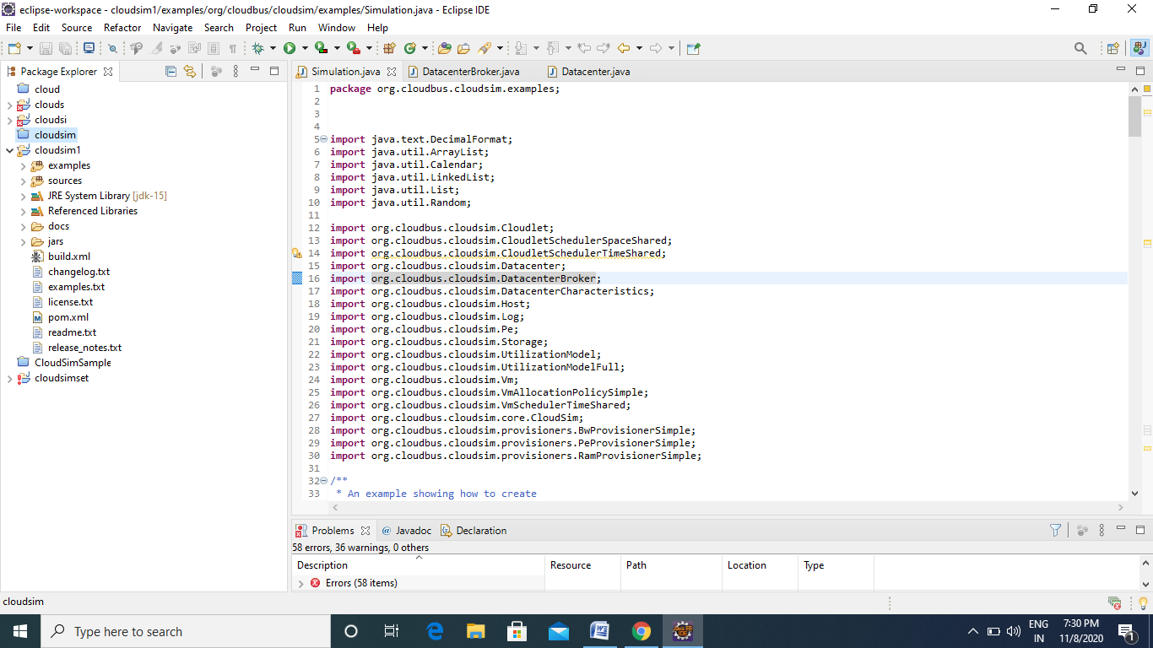

* Run the program

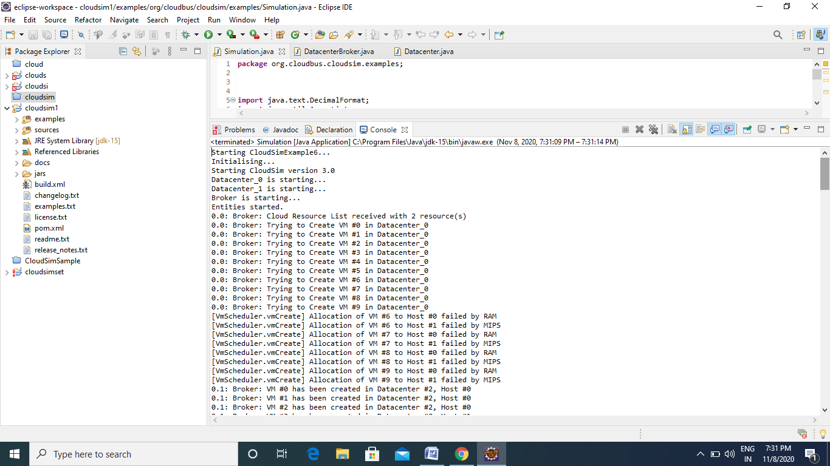

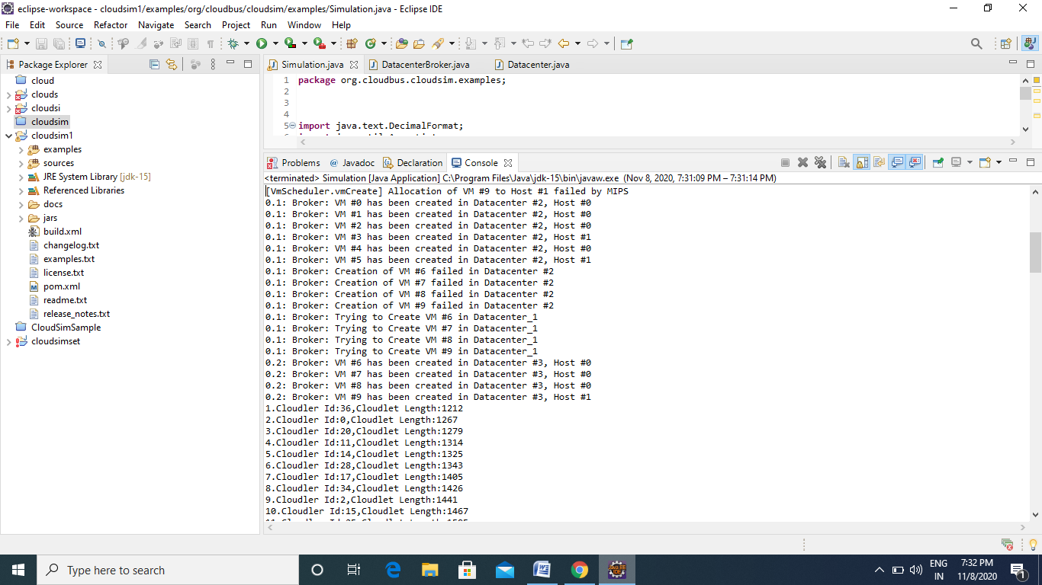

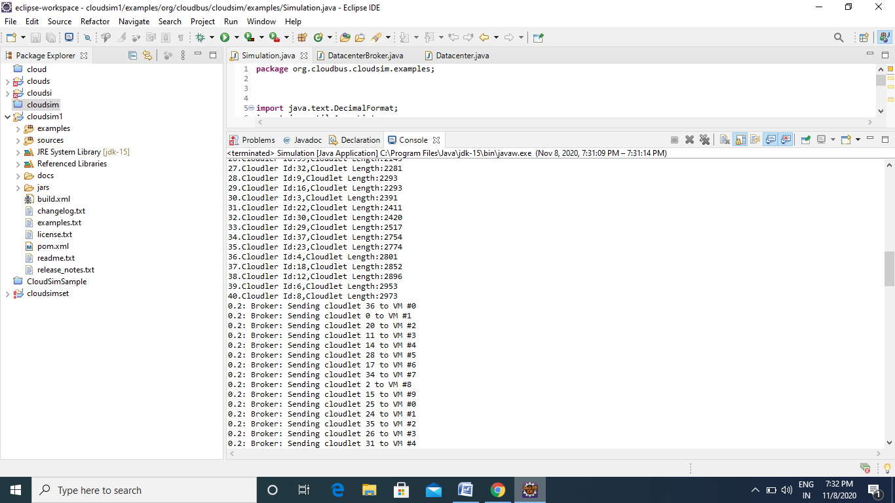

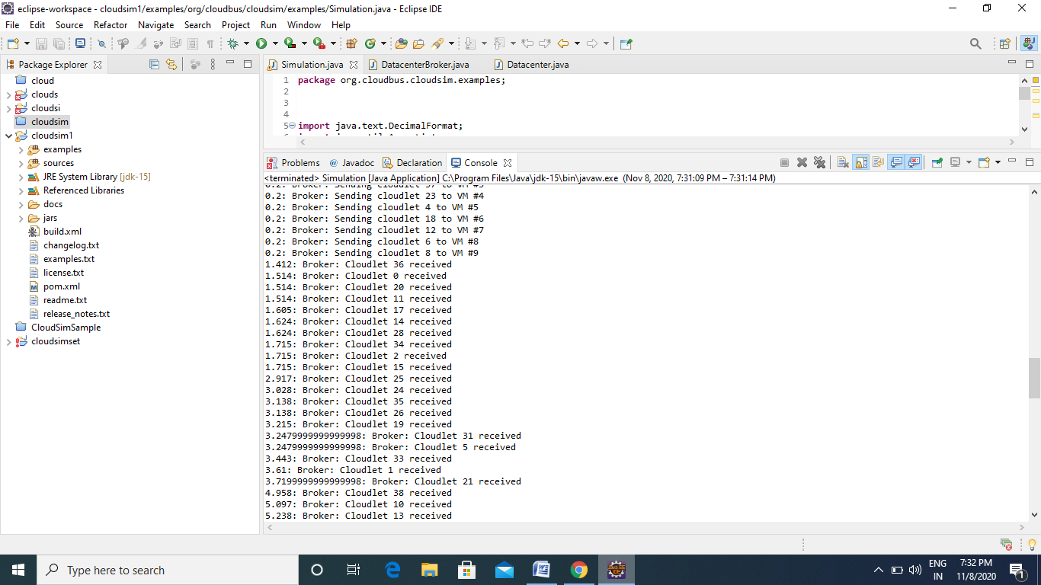

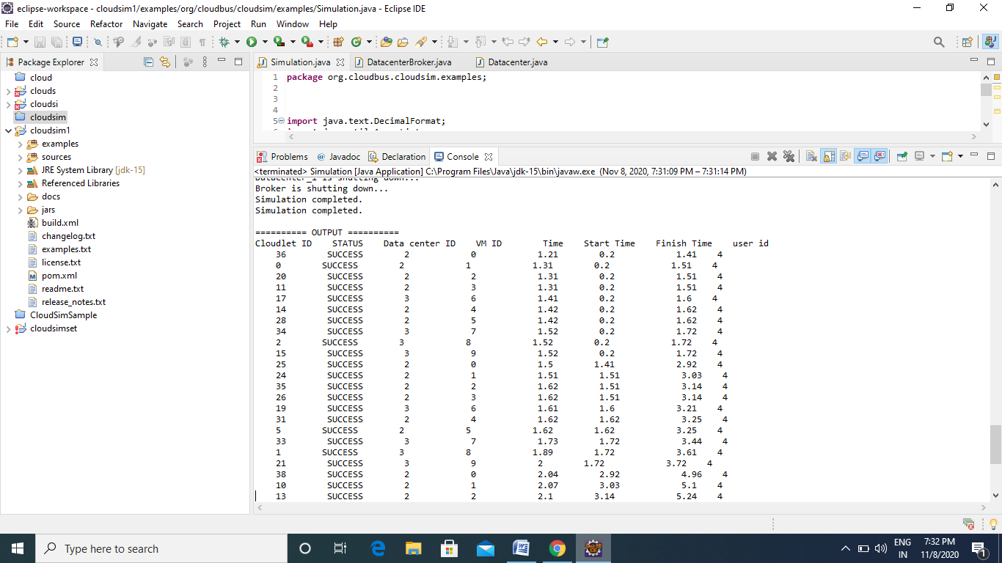

**Results:**

Thus the scheduling algorithm using cloudsim has been successfully executed.

**EX NO:8 Sharing files between VMs**

**DATE: 06.10.2020**

**Objective:**

To share a file between two virtual machines using virtual box.

**Requirement:**

* Two Virtual Environments - VM1, VM2
* Open SSH Client.

**Theory:**

Transferring files between Ubuntu and Windows can be done in many ways, but in this tutorial, we are going to discuss the following popular methods:

1. Transfer files between Ubuntu and Windows via the SSH.
2. Transfer files between Ubuntu and Windows using Samba.
3. Transfer files between Ubuntu and Windows using Shared Network Folders.

**Procedure and implementation:**

I. Create two VMs and install Ubuntu 16.04 server for AMD64 architecture. Name them as VM1 & VM2.

Install open ssh-server while installing OS.

]$ sudo apt-get install open ssh-server ]$ sudo apt-get install open ssh-client

II. Ping VM1 from VM2 and vice versa.  
III.Generate ssh public and private key pairs in VM1 & VM2 using the command ]$

IV. Exchange public keys between two VMs using ssh-copy-id command. V. File Transfer between VMs on same Host and different Hosts

1. Transfer File / Directory from VM1 to VM2 using Secure copy command (scp). 2. Transfer File / Directory from VM2 to VM1 using Secure copy command (scp). 3. Receive a file / directory from VM1 to VM2 using Secure copy command (scp). 4. Try to transfer a file from physical machine (Windows as host OS) to VM1.

5. Try to transfer a file from VM1 to physical machine (Windows as host OS).

**Step 1**. Install the SSH package on Ubuntu using the next command.

sudo apt install openssh-server

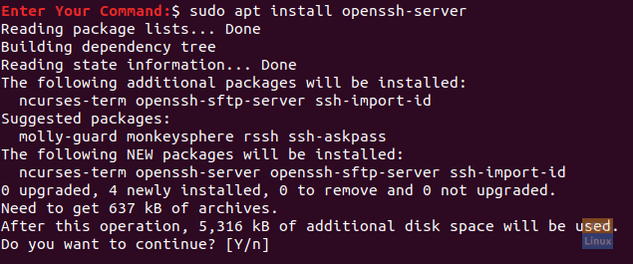

Install The Open SSH Package On Ubuntu

**Step 2**. After installation finishes successfully, you can check the SSH service status using the following command.

sudo service ssh status

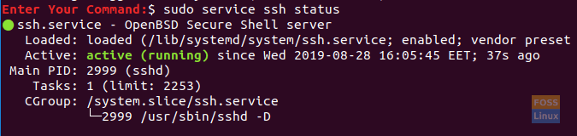

Check The SSH Service Status

If the service is not running, you can use the following command to start it:

sudo service ssh start

sudo service ssh enable

**Step 3**. Install the net-tools package.

sudo apt install net-tools

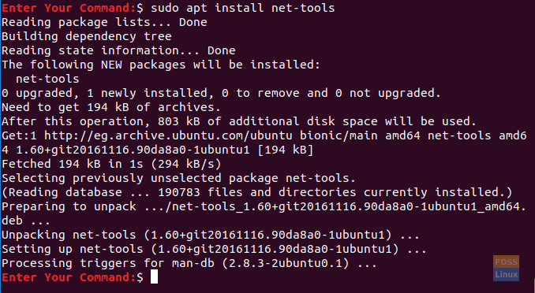

Install net-tools package

**Step 4**. Execute the next command to get your Ubuntu machine IP.

ifconfig

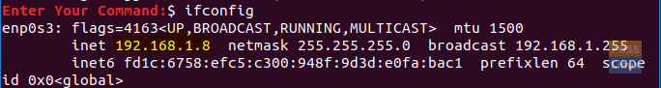

Ubuntu Machine IP

**Step 5**. From your Windows machine, we need an SSH client (which is Putty) and a PSCP. PSCP is considered a secure copy tool that is used alongside with Putty to transfer files securely over a network.

You can download both (Putty and PSCP) from the Putty official website.Kindly note that Putty will need to be installed while the PSCP won’t. You have to put the PSCP.exe in the “C:\” drive to be used, as you should see shortly.

Step 6. Now open the file explorer and use the next command to start transferring your files from your Windows machine to Ubuntu.

c:\pscp "C:\Ubuntu Tutorials\Windows Shared Folder\Windows Shared Folder.txt" hendadel@192.168.1.8:windowssharedfile.txt



Copy File From Windows To Ubuntu Via SSH

**Step 7.** Next, you should enter your Ubuntu password.

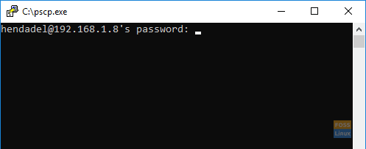

Enter Your Ubuntu Password

**Step 8**. After entering the password successfully, the command shall copy the text file from your Windows machine to your Ubuntu home. You can check your home directory now, and you should find the file there.

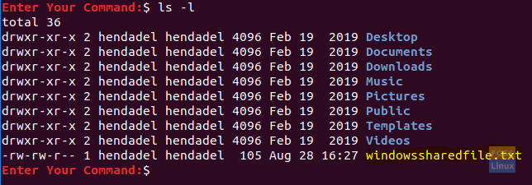

Check The Copied File

**Step 9**. Now in case you need to transfer your files from Ubuntu machine to Windows, open the file explorer from your Windows machine and use the next command. Be careful, and do not forget the dot at the end of the command.

c:\pscp hendadel@192.168.1.8:ubuntushared .

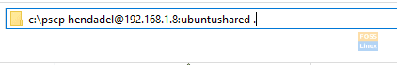

Copy File From Ubuntu To Windows Via SSH

**Step 10:** By executing the previous command, you should enter the password of your Ubuntu machine. Next, the file gets transferred from Ubuntu to the Windows current directory.



File Copied Successfully

**Results:**

Thus the file sharing between two virtual machines has been implemented successfully using open SSH client.

**EX NO:9 Trystack Virtual Machine**

**DATE: 13.10.2020**

**Objective:**

To explore trystack/openstack platform and create a virtual machine on platform managed by Openstack sandbox.

**Requirements:**

* + Web browser
  + Open stack Sandbox

**Theory:**

OpenStack is an open source platform, which offers powerful virtual servers and required services for cloud computing. It is mostly deployed as Infrastructure-as-a-service (IaaS), which aims to provide hardware tools and components for processing, storage, and networking resources throughout a data center.

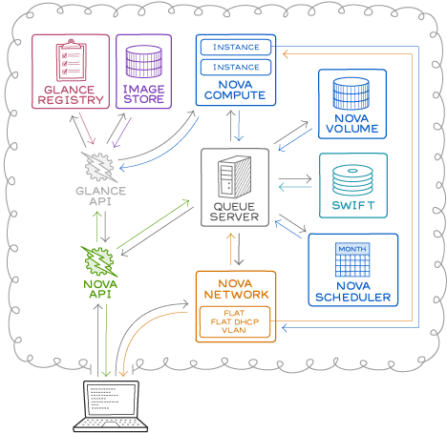

OpenStack can be understood as a software platform that uses pooled virtual resources to build and manage clouds, both public and private ones.  
By default, OpenStack offers a couple of cloud-related services like networking, storage, image services, identity, etc., and can be clubbed with a few more to get a customized cloud optimization to support the cloud-native apps.

**OpenStack community has declared around 9 components to be an integral part of OpenStack.**

They are:  
• Nova: This is the fundamental computing engine of OpenStack. It manages a large number of Virtual machines and other instances, which handle computing tasks.

• Swift: Swift is the storage system of OpenStack. It is used to store the objects and files. Instead of referring to the file and objects through the path, developers can instead refer to them through a unique identifier, which points to a file or piece of information and thereby allow the OpenStack to manage where to store the files. This reduces the effort of the developers to understand and worry about storage distribution. This also ensures that the data is being backed up, if in case of any failure of the machine or network loss.

• Cinder: Cinder is known as the block storage component of OpenStack. This functions in a way, analogous to the traditional ways of locating and accessing specific locations on a disk or a drive.  
• Neutron: As the name suggests, Neutron is the component that enables networking in OpenStack. It ensures that each component within the OpenStack is well connected with other components, to establish good communication amongst them.

• Horizon: Horizon is the dashboard of the OpenStack system. It provides all the possibilities for the system administrators to access and manage the cloud. This is the first component that everyone “sees” upon starting to use the OpenStack. Developers will be able to access and deal with all the components through the Application Programming Interface (API) also, while Horizon is the only place through which the system admins will be interacting with the OpenStack architecture.

• Keystone: Keystone is the component that provides the identity services for all the users. It basically contains a central list of all the users of the OpenStack cloud, mapped to the accessible services of the OpenStack. It provides a way for multiple accesses by allowing the developers to map their existing user access methods to the Keystone.

• Glance: Glance provides the image services in OpenStack, where images refer to the virtual copies of the hard disks. Glance helps in allocating these images to be used as templates while assigning new virtual machine instances.

• Ceilometer: Ceilometer provides telemetry services to its users. It performs a close regulation of each user's cloud components' usage and provides a bill for the services used. Think of Ceilometer as a component to meter the usage and report the same to individual users.

• Heat: Heat is that component of the OpenStack which allows developers to store the requirements of a cloud application in a file so that all the resources necessary for a program are available at hand. It thus provides an infrastructure to manage a cloud application. It is an orchestration instrument of OpenStack.

**Procedure and implementation:**

1. Setting up an account:

1.1. Visit https://platform9.com/managed-openstack/ and create a free account. 1.2. Login to the account and move to the sandbox mode.

2. Creating a VM instance:

2.1. Login and move to the Dashboard

  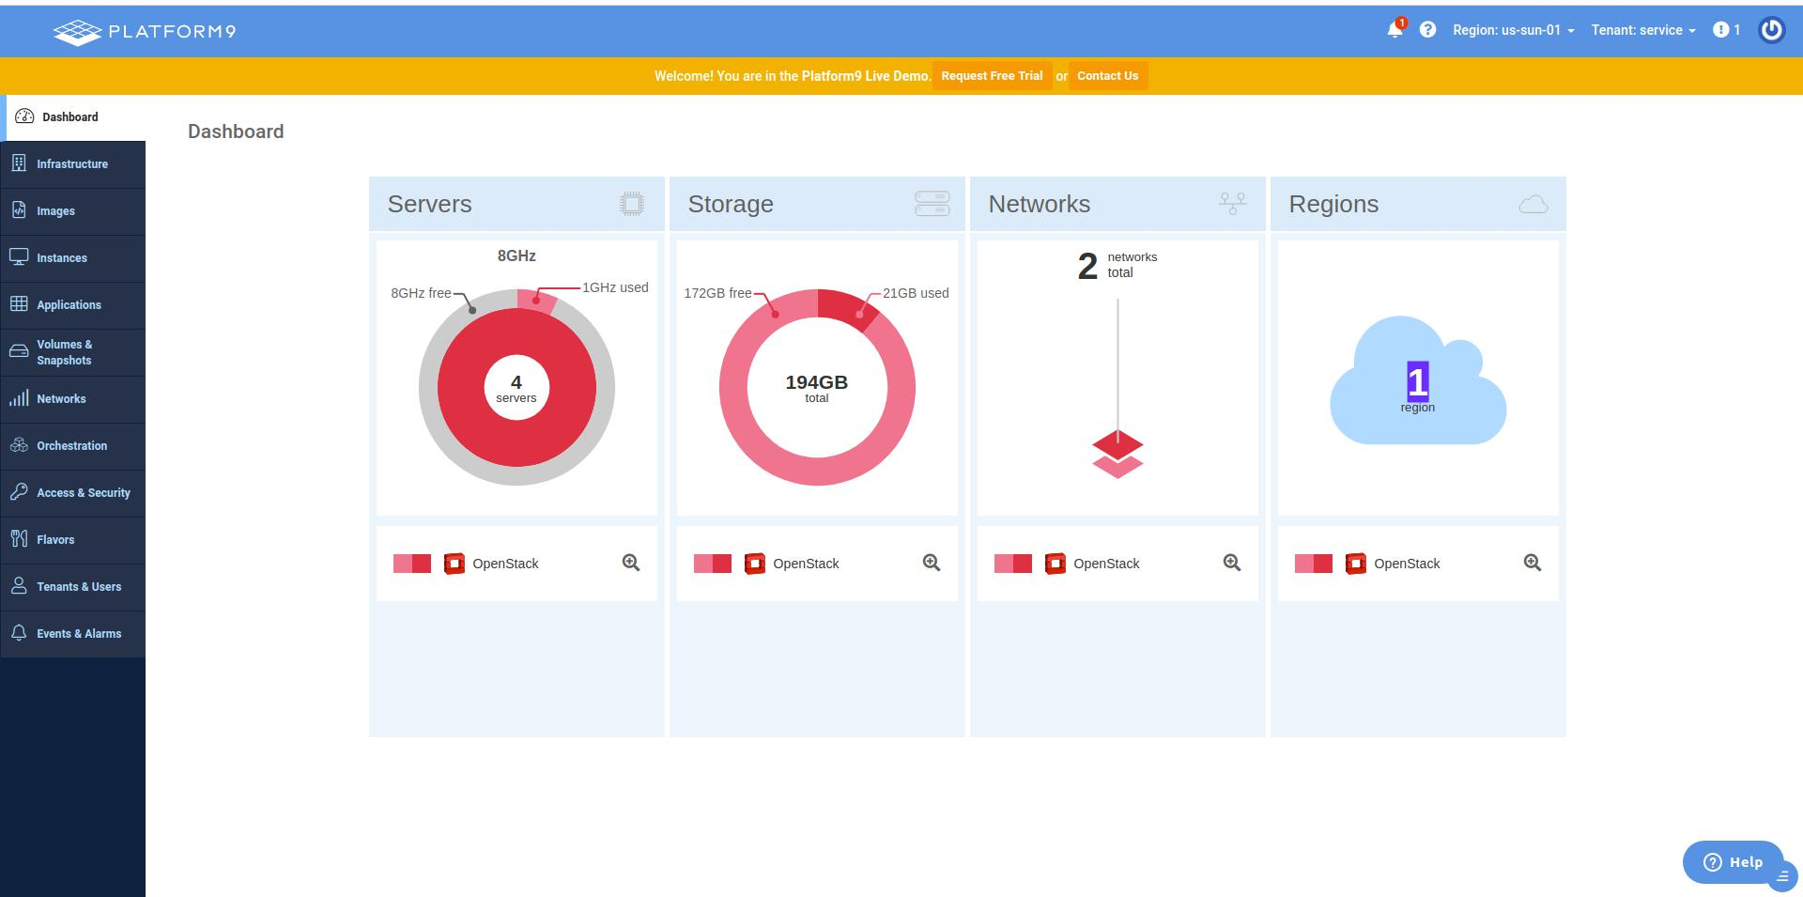

2.2 Click on the instances Tab to view current instances and choose on “create a new instance”.

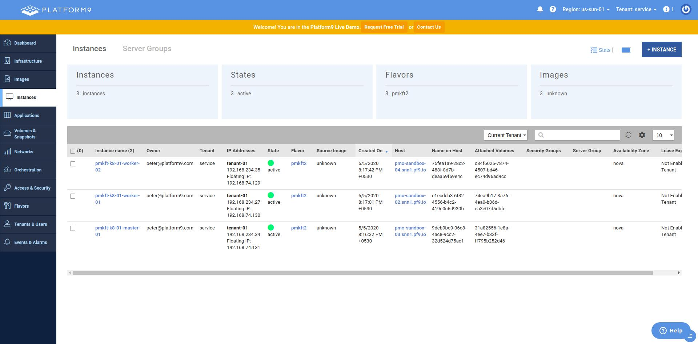

2.3 Choose an OS DISK Image to use.

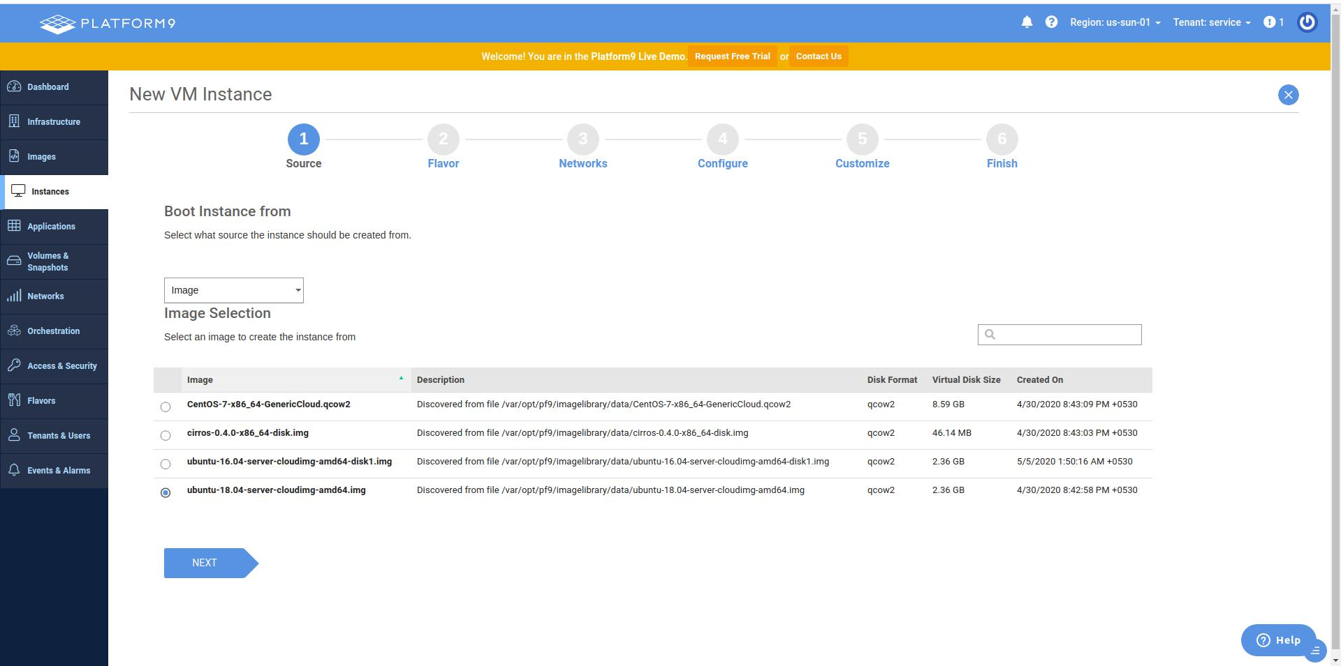

2.4 Next Choose the type of VM based on the CPU and Memory Requirements.

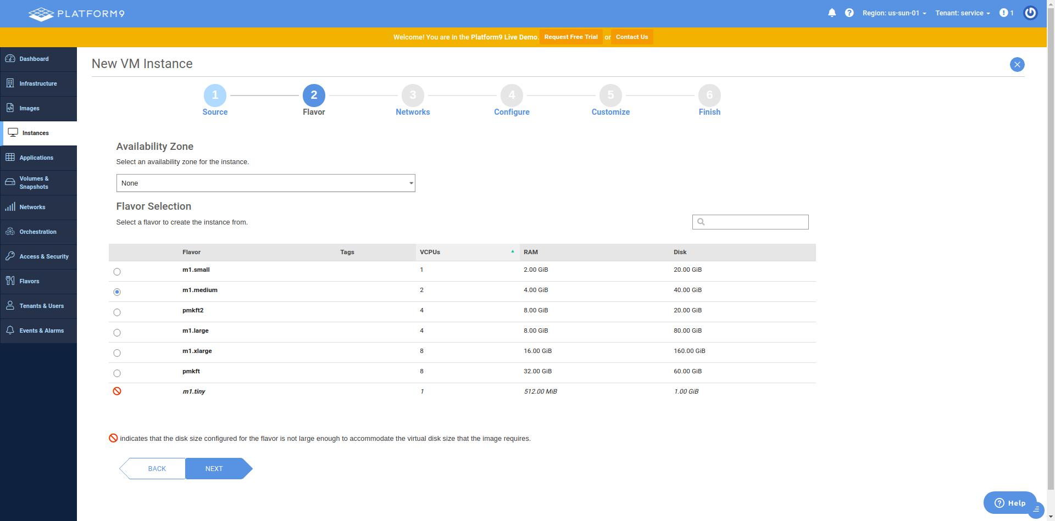

2.5 Set/Select Network configuration for the VM.

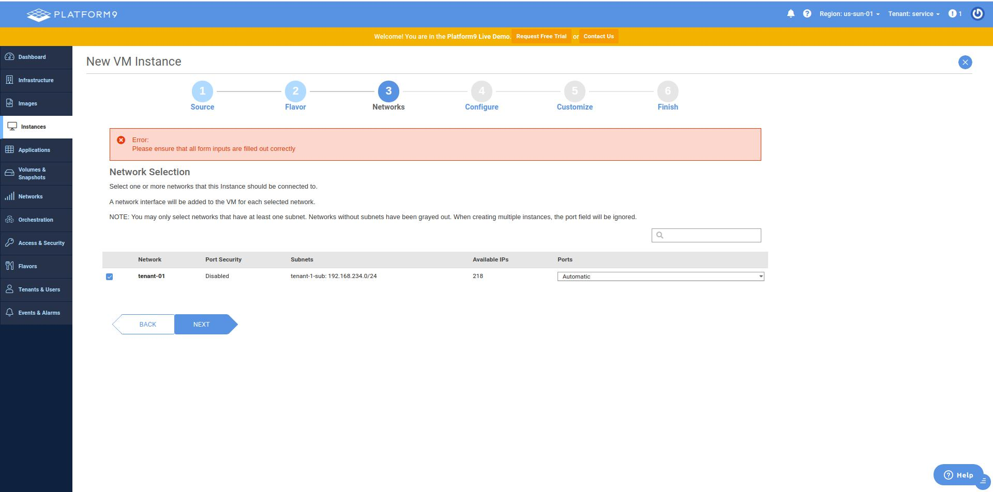

2.6 Set a name for the instance, then choose/create an ssh keypair for connecting to the VM also choose the number of such VMs to be created.

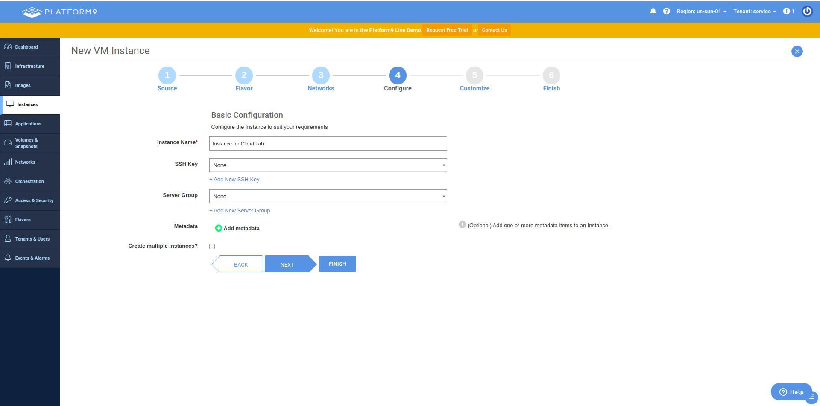

2.7 Optionally add any additional configuration for the VM.

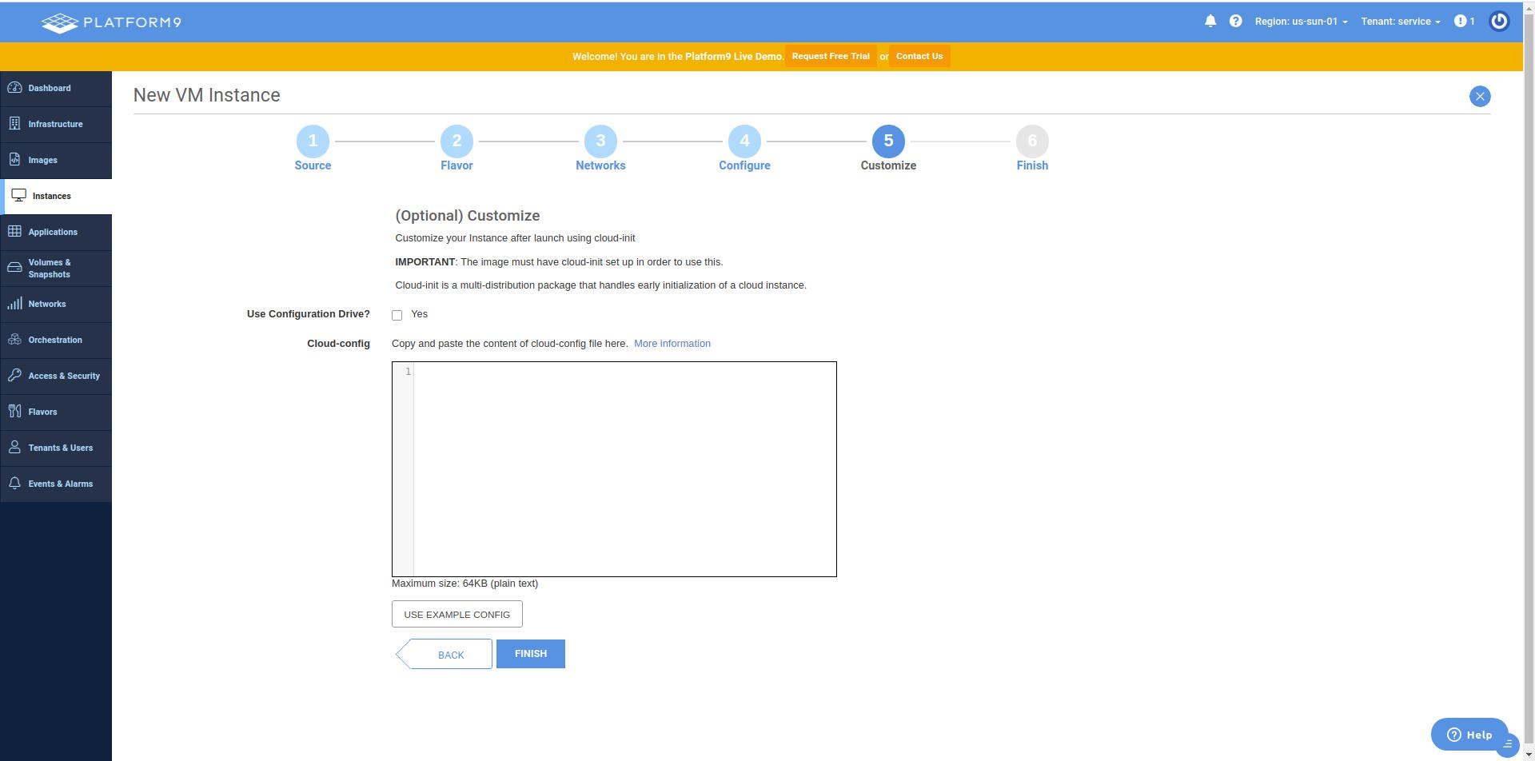

2.8 Finally, Click on “create instance” to successfully create the VM.

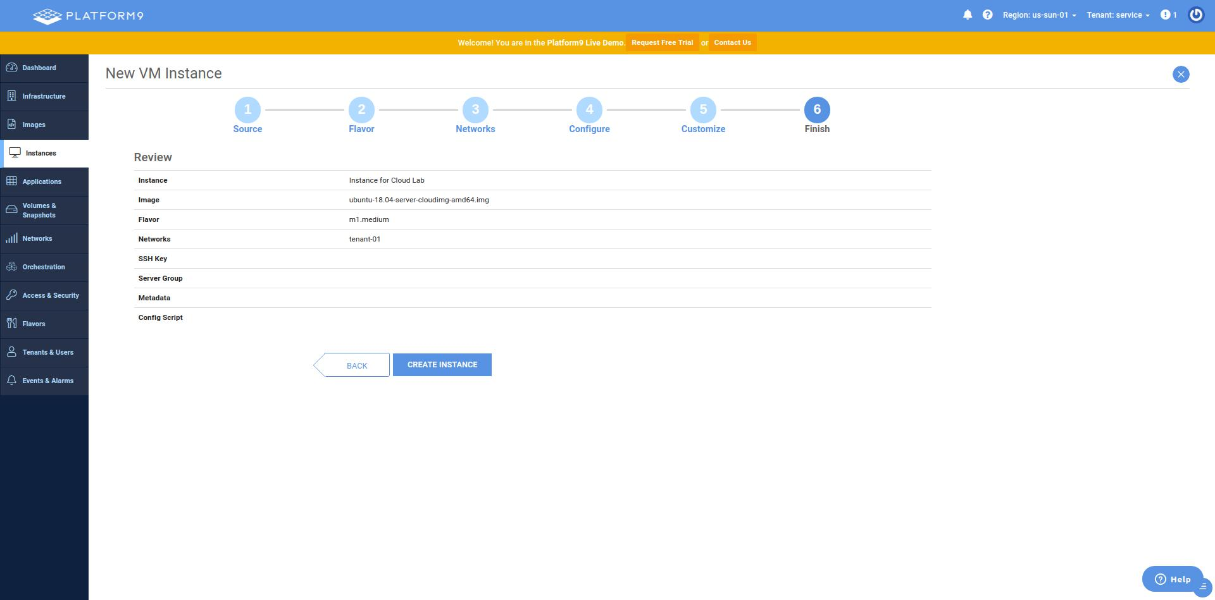

**Result:**

Trystack/Openstack was explored and a VM was successfully created on Platform9 Managed Openstack sandbox.

**EX NO:10 Hadoop and Word Count**

**DATE: 20.10.2020**

**Objective:**

To understand the features of Hadoop and to implement a word count program.

**Requirement:**

* 1. OperatingSystem:Ubuntu16.04LTSDesktop(64-Bits only)OS
  2. InstallationMode: Installing GuestOS(Note:Virtual Machine can be slower   
     to work when Hadoop Cluster starts)
  3. Java: JDK 1.8
  4. Download latest version of Apache Hadoop package
  5. Eclipse Luna 64-bit for Linux (Can be downloaded from SSN Intranet –   
     Tech Support). Install Eclipse. (If Necessary)
  6. Create a Virtual Machine and install Ubuntu 16.04 Desktop AMD 64.iso in   
     VM. Name the VM as HadoopVM and set network configuration.

**Theory:**

The Apache™ Hadoop project develops open-source software for reliable, scalable, distributed computing.

The Apache Hadoop software library is a framework that allows for the distributed processing of large data sets across clusters of computers using simple programming models. It is designed to scale up from single servers to thousands of machines, each offering local computation and storage. Rather than rely on hardware to deliver high-availability, the library itself is designed to detect and handle failures at the application layer, so delivering a highly-available service on top of a cluster of computers, each of which may be prone to failures.

Apache Hadoop is an open source framework that is used to efficiently store and process large datasets ranging in size from gigabytes to petabytes of data. Instead of using one large computer to store and process the data, Hadoop allows clustering multiple computers to analyze massive datasets in parallel more quickly.

**MapReduce** is a processing technique and a program model for distributed computing based on java. The MapReduce algorithm contains two important tasks, namely Map and Reduce. Map takes a set of data and converts it into another set of data, where individual elements are broken down into tuples (key/value pairs). Secondly, reduce task, which takes the output from a map as an input and combines those data tuples into a smaller set of tuples. As the sequence of the name MapReduce implies, the reduce task is always performed after the map job.

**Procedure and Implementation:**

Hado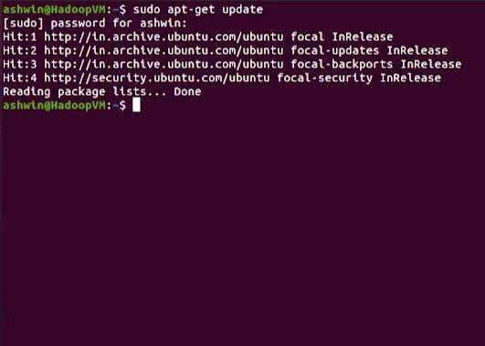opVM :

➔  Create a New Ubuntu 20.04 Desktop VM .   
 ➔  Provide 1Gb Ram and 20 Gb Disk space .   
 ➔  Launch the VM .   
Hadoop Installation in HadoopVM :  
➔ Update Ubuntu using sudo apt-get update .

➔ Create a New User ‘Hadoop’ and add it to the sudo users list .

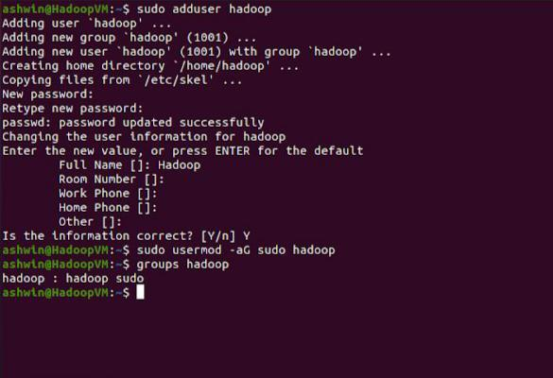

➔ Install java using sudo apt-get install default-jdk default-jre and check java -version .

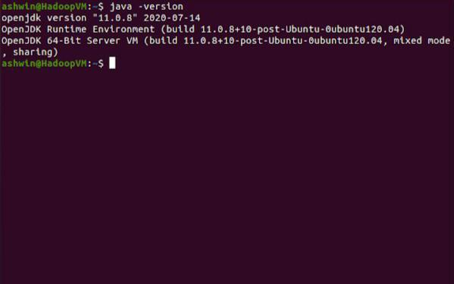

➔ Login to New User and install SSH .

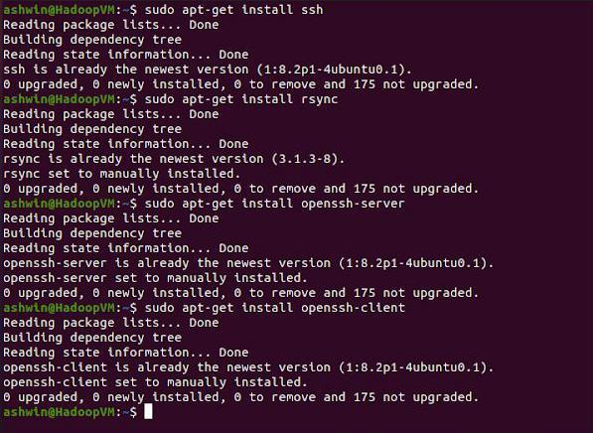

➔ Create SSH Key Pair and move it to Authorized_Keys.

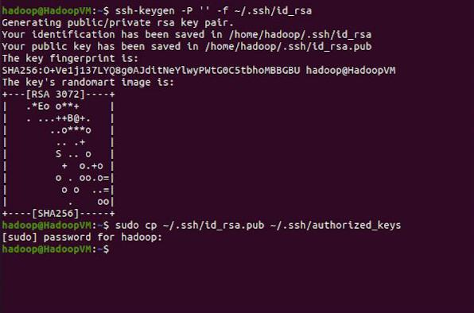

➔ Verify SSH Login using ssh localhost .

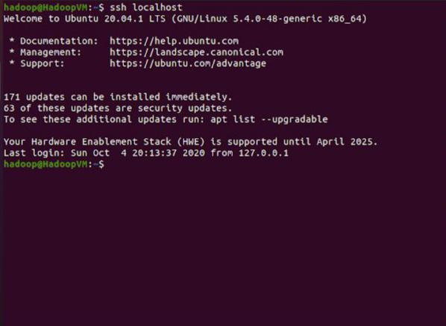

➔ Download Hadoop Files and move them to Hadoop Directory .

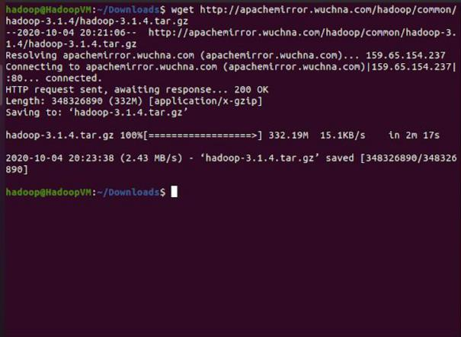

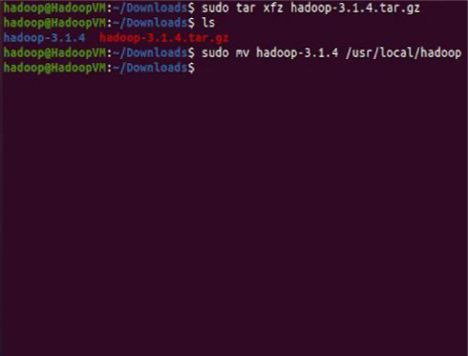

➔ Include Java_Home variable to hadoop_env.sh .

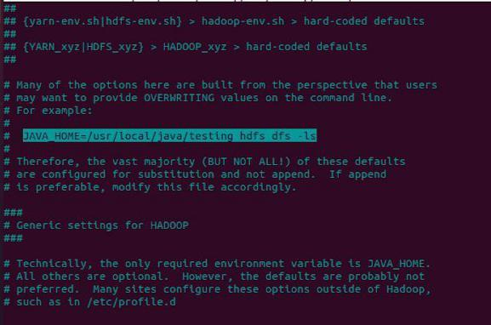

➔ Include Java Path variables and Hadoop variables to bashrc .

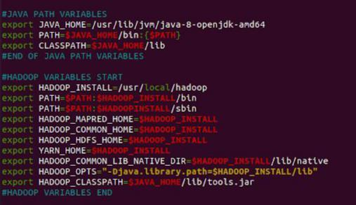

➔ Check Hadoop Version .

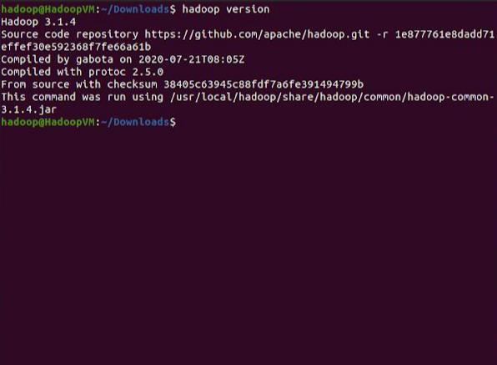

➔ Include properties to core-site.xml configuration .

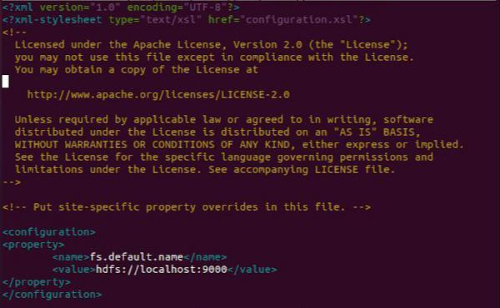

➔ Include properties to yarn-site.xml configuration .

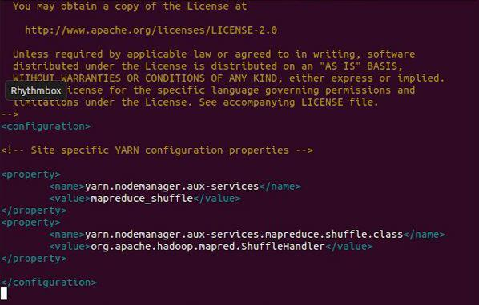

➔ Include properties to mapred-site.xml configuration .

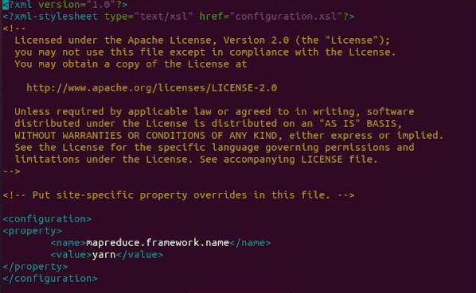

➔ Include properties to hdfs-site.xml configuration .

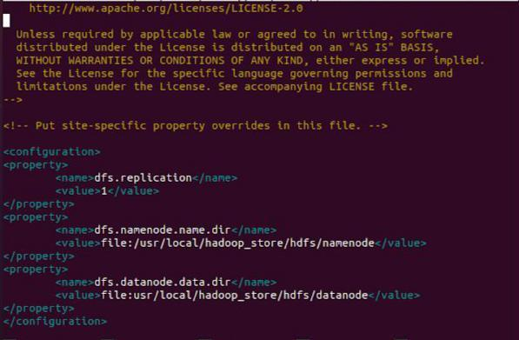

➔ Change Ownership and Mode for the hdfs directories .

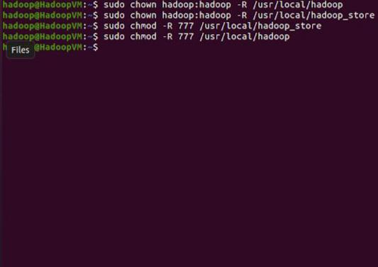

➔ Start the Hadoop services . Run jps to view the running process and id .

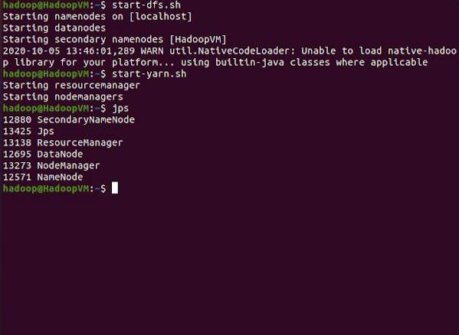

➔ Check the running services in Web Interface . ➢ Port 9870 :

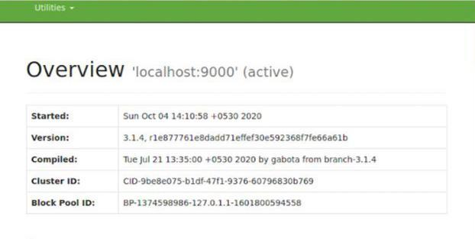

➢ Resource Manager :

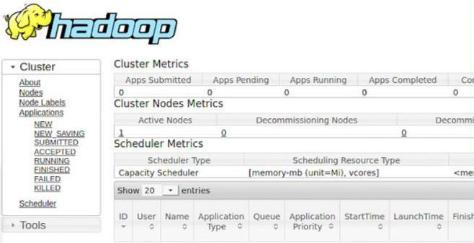

➢ Node Manager :

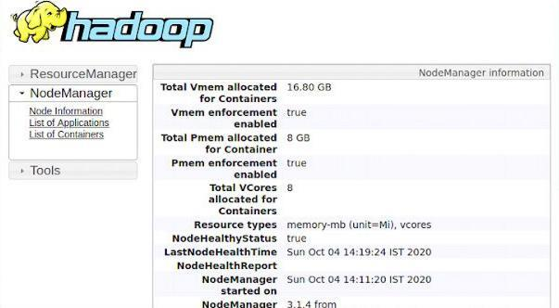

❖ Running Word Count program in Hadoop :  
➔ Create Directories for Input , Output and Upload the Input and Text File .

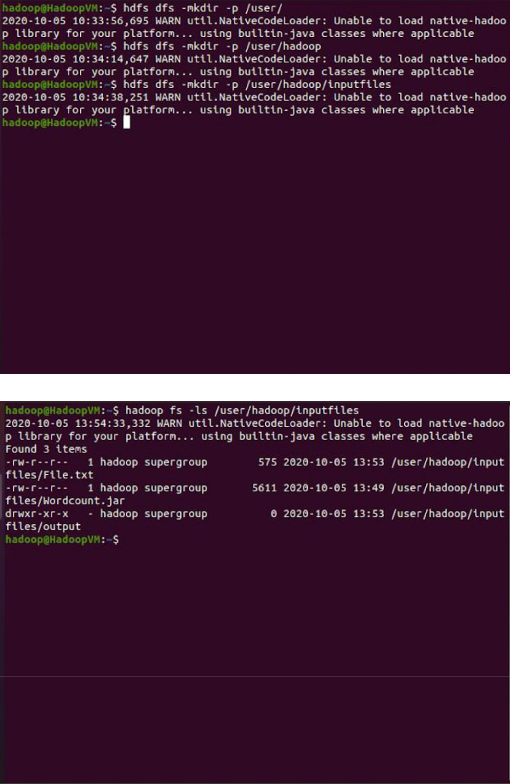

➔ Create a Word Count program and compile it to create a jar file .

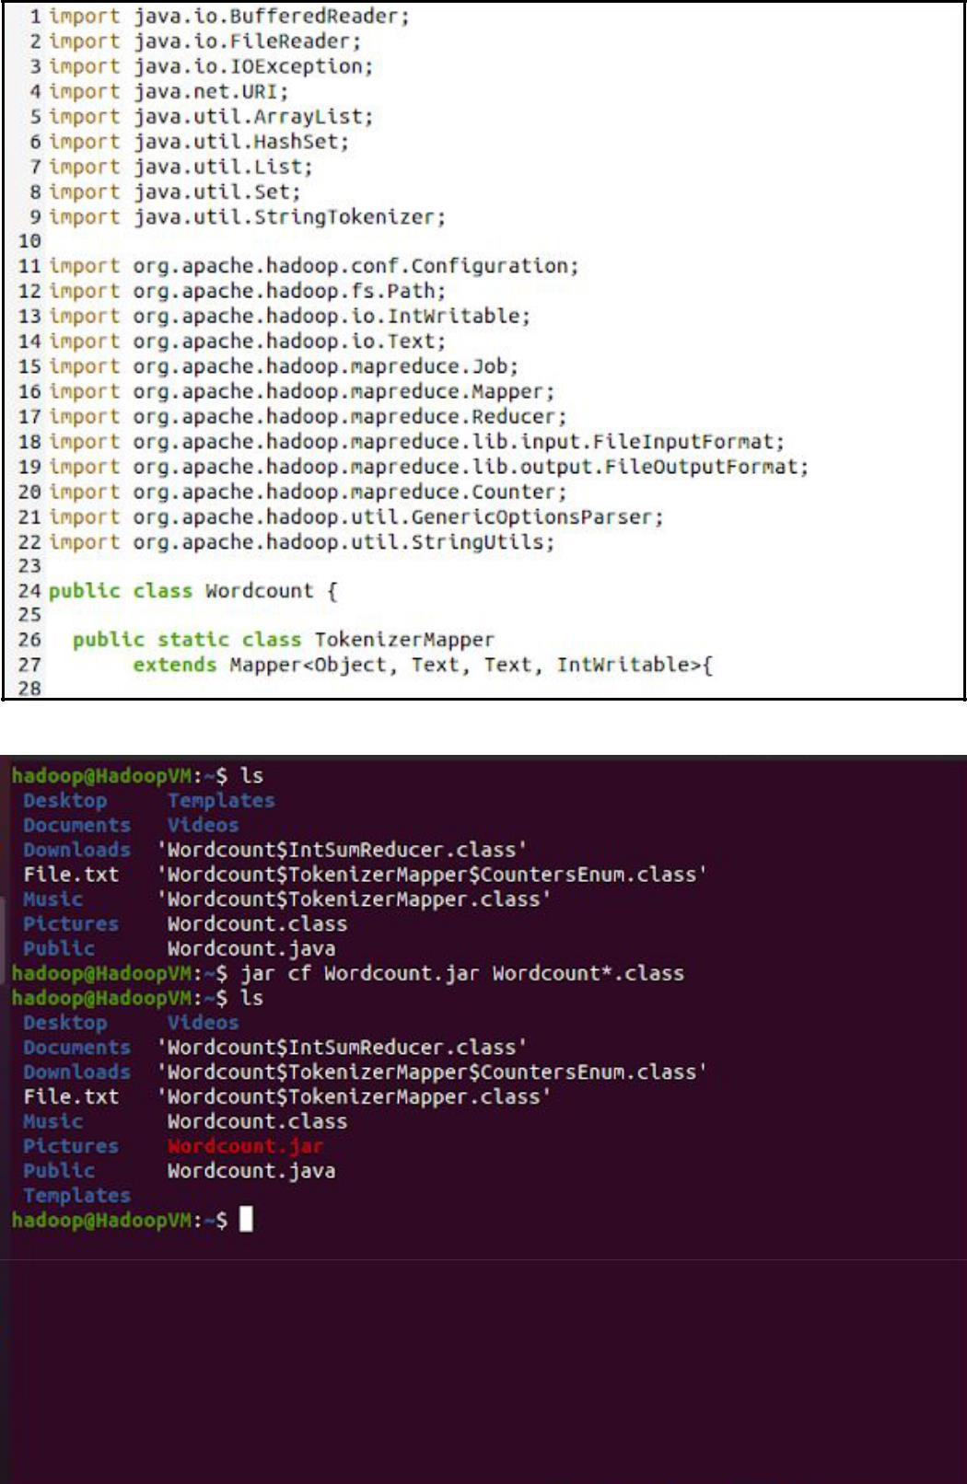

➔ Run the jar using hadoop command hadoop jar <jar> <classfile> <inputfilepath> <outputfilepath> .

➔ View the contents of the output file , it should contain words and their frequency in the Text File .

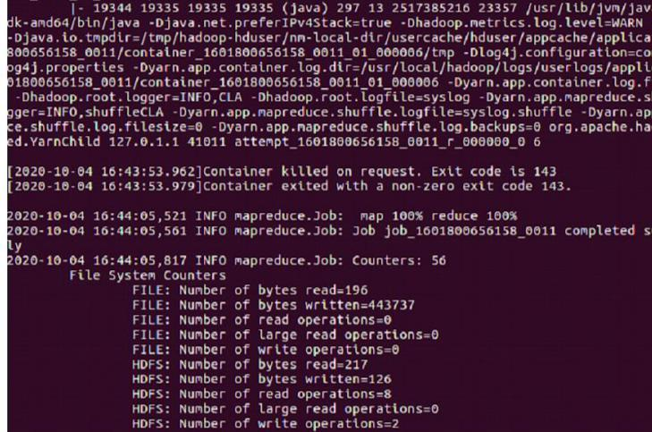 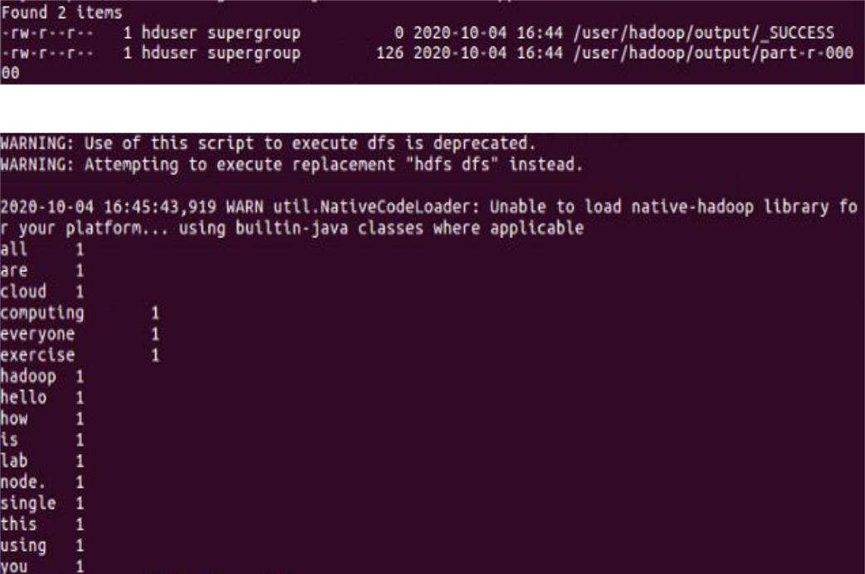

➔ Stop all Hadoop services .

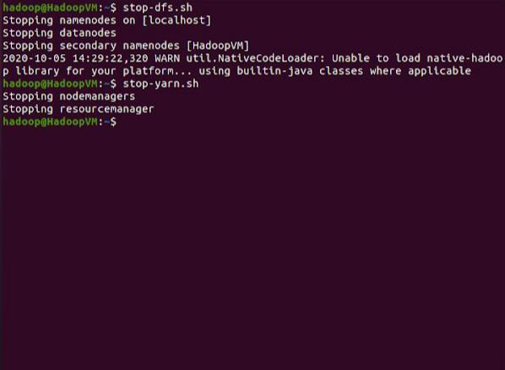

**Result:**

Thus the Single node Hadoop platform has been installed and Word count program has been implemented successfully.